Brabin’s Endowed Primary School 

Addendum: Online Safety Policy

Brabin’s Endowed Primary School is committed to providing a safe environment for online learning. This commitment remains the same in the difficult circumstances brought about by the COVID-19 outbreak. During the period of Home Learning, our expectations of staff and pupils also remain the same in relation to the principles and practices of the school’s Safeguarding and Child Protection Policy and Online Safety Policy. The staff Code of Conduct will also continue to apply, both to existing and any new online and distance learning arrangements introduced. Staff and pupils must review these policies and ensure that they adhere to them at all times.
In order to ensure the safety and welfare of children during this period, pupils are engaging in guided home learning. The school will follow the DfE remote learning guidance:
https://www.gov.uk/guidance/safeguarding-and-remote-education-during-coronavirus-covid-19

Given the changes in circumstances to everyday teaching and learning practices, the following guidelines will also apply:
Providing a safe system
- Where the site remains open, the school will continue to ensure that appropriate filters and monitoring systems are in place. This is to protect children when they are online using the school’s IT systems/ recommended resources.
- For the purposes of guided home learning, the primary platforms used across the school’s network are:
o Microsoft Teams
o Seesaw
The online safety implications of any platform are carefully considered before use and staff should only use pre-approved platforms.
- The school’s Designated Safeguarding Lead (DSL) has day to day responsibility for online safety and will maintain an active oversight of the management of guided home learning from a safeguarding perspective. Procedures will be kept under review and action will be taken swiftly if concerns about the use of technologies arise.
- The school will keep in regular contact with parents, updating them as appropriate with information on how the school is providing guided home learning, how they can keep their children safe online and any new developments.

Guided home learning
There is a wide range of formats for guided home learning, including:
- Posting activities/tasks for pupils on a weekly basis through Seesaw with pupils and teachers posting responses
- Directing pupils to web-based resources and activities they can engage with on, or, offline, e.g. Oak Academy
- Interactive/live teaching in real time

Teachers will select the most appropriate format for a lesson depending on a number of factors, including the age of the pupils, size of the group, nature of the activity, and the degree of support required. Teachers will take into account the need to ration screen time and provide a variety of learning experiences within a lesson, across the school day/week and through a scheme of work.
Live online communication
Live online communication is an important part of this overall package for pupils of all ages. Interaction with a teacher is an important part of the learning process, and whilst online contact cannot replicate face to face contact, live sessions are particularly helpful as they allow contemporaneous communication, as pupils are able to respond to staff questions – and vice versa. Live contact is an important part of pastoral support and provides pupils with a direct interface with a familiar trusted figure at a time of significant change and uncertainty. Live sessions also give pupils the opportunity to interact with peers and maintain important social connections during a period when they could otherwise become isolated.
However, it should be remembered that live online communication remains ‘one tool in the box’ and, for the reasons set out above, it should be balanced alongside other formats of learning opportunities.
In order to safeguard both pupils and staff, live online sessions must be conducted following the protocols set out below:
Protocols for staff in relation to guided home learning:
- Only use school approved platforms; do not use social media in communicating with pupils
- Reinforce online safety messages regularly in your teaching
- Bear in mind the current circumstances and how they are affecting children and families in regard of expectations
- Consider online safety when sharing resources – check websites and videos/apps/software carefully and bear in mind that the home environment will not have the same content filtering systems as at school. If introducing new apps and resources, ensure these meet GDPR requirements.
- If concerned about online safety/resources, check with the Headteacher
- Ensure that passwords and secure information – such as log-ins are kept confidential
- Adhere to copyright and GDPR guidelines
- Continue to look out for signs that a child may be at risk – which may differ from typical triggers in a school environment. Report any concerns to the DSL without delay and in the usual way
- Do not provide pupils or parents with personal contact details – email, home or mobile numbers, details of web-based identities etc.
- Do not arrange to meet pupils, or, ask them to deliver work to your home
- Remain professional and objective in all forms of correspondence

In relation to live online sessions:
- Record any incidents. Any serious incidents should be reported in the usual manner depending on the nature of the issue.
- Maintain professional conduct during live streaming – dress appropriately, consider your surroundings (background, other household members who may come into view etc.) and blur if necessary. Remember that a microphone may be on.
- Maintain the same boundaries and insist on the same standard of behaviour as in a school setting. Make specific protocols clear at the outset, e.g. muting of microphones at appropriate times, use of the chat function etc.

Reporting an issue for staff:
- Any child protection, or, safeguarding concern must be reported to the DSL without delay.
- Concerns about the safety of procedures, behaviours, or, use of technology should be referred to the DSL
- Routine queries about the use of apps, or, online materials should be addressed to the headteacher
- UKSIC’s Professionals Online Safety Helpline is a good source of external advice

Protocols for pupils in relation to guided home learning:
- Always log on through the school account
- Do not make recordings, take screenshots/screengrabs or photographs, or store footage of teachers or of other pupils
- Be aware that some live online sessions may be recorded by the teacher
- Dress appropriately for online lessons
- Ensure that you have a safe and appropriate place to participate in lessons. Blur your background if necessary
- Follow the school rules regarding conduct during online lessons as if you were in school and follow the SAFE acceptable user agreement – see below
- Do not undermine in any way the technology used to offer video sessions
- If you have concerns about online safety, or if you feel you are being bullied, talk to someone you trust

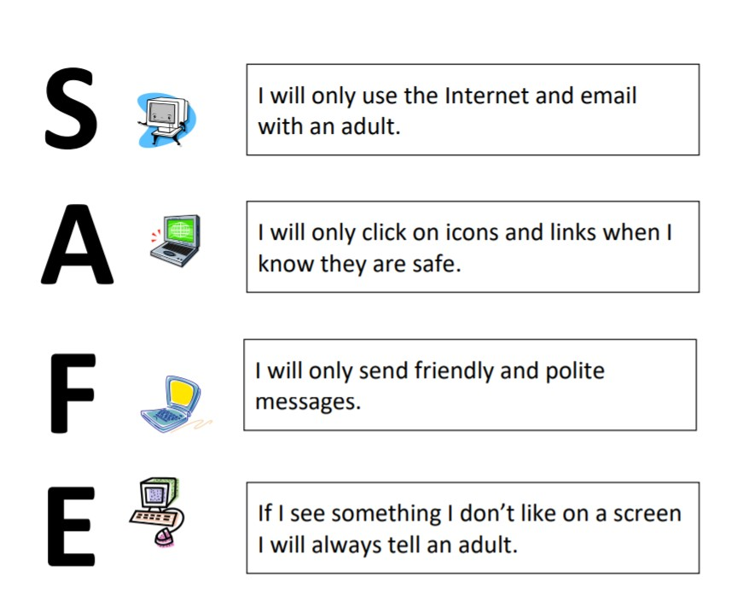

Reporting an issue for pupils:
- Speak to a trusted adult
- Email your class teacher or use Seesaw to make contact
- Contact Childline 0800 1111 or click CEOP https://www.ceop.police.uk/safety-centre/

The role of parents
- It is the responsibility of parents to ensure that pupils are monitored in their use of technology for guided home learning as they would ordinarily do when their children are using technology at home. Monitoring screen time is particularly important in the current circumstances
- Whilst pupils are working from home they are connected to their home broadband so their traffic doesn’t go through the school firewall – parents will therefore need to ensure that age-appropriate filtering or safe search is enabled at home. Information on setting this up can be found at: https://www.saferinternet.org.uk/advice-centre/parents-andcarers/parental-controls-offered-your-home-internet-provider or:
https://www.internetmatters.org/parental-controls/
- Communication during online sessions is between pupil and teacher: parents should communicate with school/staff in the usual manner, via school email or telephone during a period of guided home learning
- Any parent wishing to supplement the school’s guided home learning with support from online companies or individual tutors should be mindful of the importance of using reputable organisations or individuals who can provide evidence that they are safe and can be trusted to have access to children – further information can be found in the sources of support below
- Social media, networking apps and gaming platforms are particularly popular at the moment. Parents are advised to be mindful of age restrictions and to oversee their child’s social media activity
- The school will update parents regularly on online safety matters. Parents are requested to heed the school’s advice and contact the school if they have concerns or encounter risk online.

Reporting an issue for parents:
- Contact the DSL (Mrs Wallace) for any safeguarding or child protection or online safety concern.
- You can also report an incident to CEOP https://www.thinkuknow.co.uk/parents/Gethelp/Reporting-an-incident/ or Report Harmful Content https://reportharmfulcontent.com/
- Contact your child’s class teacher in the usual way for routine queries about guided home learning
- See the sources of support and advice below

Sources of support and advice
- UK Safer Internet Centre https://www.saferinternet.org.uk/ - includes a range of activities for children of different ages
- CEOP / Thinkuknow https://www.thinkuknow.co.uk/ - includes a range of home activity packs
- National Online Safety https://nationalonlinesafety.com/ - Good guides for parents and staff
- Parent Info https://parentinfo.org/ - specifically aimed at parents
- Internet Matters https://www.internetmatters.org/ - specifically aimed at parents
- Net Aware https://www.net-aware.org.uk/ - NSPCC’s advice on online matters
- Digital 5 a Day https://www.childrenscommissioner.gov.uk/wpcontent/uploads/2019/06/childrens-commissioners-office-digital-5-a-day.pdf

Agreed by the school Governors: January 2021

Review date: when required

