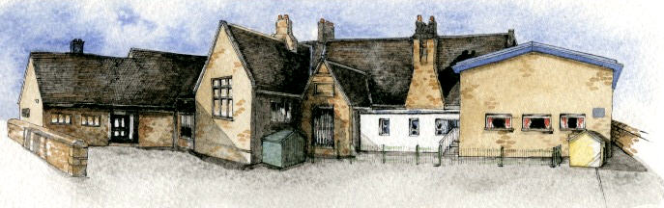
Brabin’s
Newsletter
21st January 2021
BRABIN’S ENDOWED PRIMARY SCHOOL

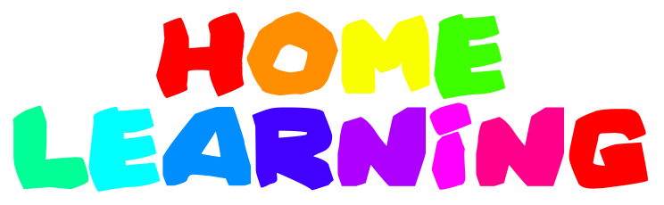  We are delighted with the overall engagement with the daily, live lessons. We thank you for your patience with early technical issues and as we all get used to new learning platforms and ‘such’ technologies. I’m sure that the sessions will run more smoothly! We hope that these daily lessons provide structure and routine for the children. It has certainly been lovely to see the children enjoying being together and connected as a class- albeit in a different way! Weekly home learning packs will continue to be uploaded, on Seesaw, ready for the week ahead.  We appreciate that families are having to manage a range of circumstances- however, we would be grateful if completed work could be shared with class teachers on a regular basis (rather than uploading lots of work at once) This will allow feedback to be given to the children in a timely manner. There has been some excellent, high quality work shared by the children on Seesaw ; it is evident that there is lots of hard work taking place! Well done to all! |  | School website  Updated policies, notices and information relating to the school closure and remote learning will be available to view on the new ‘Covid 19 Information’ tab on the school website.  New information to be uploaded next week includes: Information for parents on remote learning and Policy Addendums for Online Safety and Safeguarding.    Parent Governor Election  Parent governor nomination forms were emailed on the 12th January 2021.  If you would like to nominate yourself for the role, please could you complete both the nomination form and the biographical details form and return both to school by  noon on Monday 25th January 2021.    School Support  Please contact the school if you require any further support; whether this is regarding help with devices, school work or any other support we may be able to offer. |  |   £619 was raised from the Christmas raffle! Thank you to everyone who supported this fundraiser!  This year we have plans to improve our outdoor areas so your continued support is much appreciated.    Information regarding assessments/Tests in 2021  The Department for Education has announced that the usual assessments and tests will not take place in the summer term due to the impact of the Covid 19 pandemic.  Further information regarding assessments will follow in due course.    And finally…  If you feel that your child deserves special recognition during the current school closure – please let us know. It would be lovely to celebrate and recognise the children’s achievements whilst working at home!


A group of Chipping ladies- including 3 of our parents will be completing the Yorkshire Three Peaks in aid of The Alzhemer’s Society. Well done – and good luck!
Information below if you would like to support:
http://www.justgiving.com/fundraising/chippingladies

