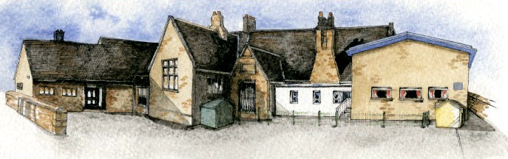

**Writing Opportunities**-

The children will write innovated stories about dragons and innovated poems about fire.

They will write setting descriptions based on The Snow Dragon

Diary entries about The Great Fire of London

Weather reports in science

**Key Learning Overview;-**

**Science –** The children will observe changes across the four seasons and will observe and describe weather associated with the seasons and how day length varies. (This will be ongoing throughout the year.)

**History-** The children will identify some similarities and differences between their way of life and the way of life during the Great Fire of London in 1666. They will ask and answer questions about the past, using a range of sources. They will also learn some of the important events from the Great Fire of London.

**Design Technology-** The children will design and make a picture with a moving part to reflect an event from the Great Fire of London. They will talk about their design as it develops and identify good and bad points, making modifications where necessary.

**Music-** The children will learn to use their voices expressively by singing songs and speaking chants and rhymes. They will also listen to music and songs inspired by the theme of fire and fireworks. They will work collaboratively to compose their own piece of ‘fire’ music.



Class: Elm Class Year 1/2 Term: Autumn 2

**Curriculum Unit – Fire! Fire!**

**BRABIN’S ENDOWED PRIMARY SCHOOL**

**Class Novel, key texts and extracts-**

The Snow Dragon by Vivian French

Zog by Julia Donaldson

London’s Burning Rhyme

London Bridge is Falling Down

* Be Curious: Show an interest in life in the past

*Use a range of sources to ask and answer questions

* Be Knowledgeable: Secure an understanding of life in the past in London 1666.
* Be Adventurous: Appreciate and perform songs from an eclectic range of styles and genres
* Be Ambitious: Strive for improvement
* Be Creative: Apply new skills to produce their own moving picture. *Create their own music.
* Be Collaborative: Work with others to sing songs and produce music.
* Be Reflective: Evaluate their own work to make improvements *Recognise positive points
* Be Positive: Develop their own opinions about their work *Listen to and respond to advice

Where is London?

What is it like today?

How can we find out what London was like in 1666?

Can we sequence the events of the Great Fire of London?

How are moving parts in books made?

How can we make a moving part for an image of the Great Fire of London?

How have different musicians been inspired by the theme of fire?

Can we work collaboratively to produce our own fire music using instruments?

**Curriculum Shapers**

**Key Questions**