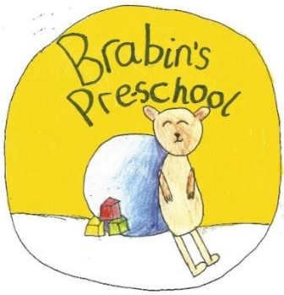
Brabin’s Pre-School
Newsletter
December 2020

We have nearly completed our first full term at Brabin’s Pre School and what a great first term it has been!  It has been wonderful to welcome 9 new children to our setting and to see them settle so well. It has also been a pleasure to work with our new families and we appreciate your support over recent months.  The Pre-School room has continued to develop over time and it has become a fantastic learning environment for our children. Staff have worked incredibly hard to provide such a stimulating environment. Further to this, lovely relationships have been formed. I thank Miss Strickland and the team for their hard work and commitment over the term.  We look forward to welcoming some more children in January and to see our setting continue to flourish in the new year.  I wish you all a very happy Christmas and hope that you enjoy the festive period as a family.  Many thanks for your continued support and we look forward to welcoming the children back on 4th January 2021!  Keep safe Mrs Wallace |  | A phonics video has been added to the Pre-School page of the school website showing how the children are taught to pronounce all the letters of the alphabet. We hope you find this useful!  Christmas Events 2020  Christmas Party Day – Wednesday 16th December.  Children are welcome to attend pre-school in non-uniform.  Christmas Nativity  The children will perform ‘We’re going on a baby hunt’  As we can’t invite parents to watch our nativity this year, we will be recording our production on Wednesday 16th and sending it to parents.  Christmas Panto  On Friday 18th December we will be experiencing the interactive pantomime film ‘Lost in Limbo Land’, which has recently been featured on BBC Breakfast this morning.  Pupils can wear their Christmas jumpers on this day.  New Year Topic  After Christmas we will be starting our new topic “Down on the farm.” As part of this topic we are planning a trip to the Wild Boar Park. More information will follow when we return in January.
Primary and School Admissions for
September 2021
Apply for a school place online at:
https://www.lancashire.gov.uk/children-education-families/schools/apply-for-a-school-place/
Closing date for applications: 15 January 2021

Christmas Post Office
We have recently read the story, “The Jolly Postman's Christmas” and decided to create a Christmas post office in our role play area. The children have enjoyed sending letters, writing christmas cards and posting them in the post box.
We also posted our own letter to Father Christmas asking him some questions and we received a very special reply and found some mysterious elf footprints in our pre-school!
