Date policy reviewed: November 2020
*Please see Covid 19 Addendum for Behaviour Policy– Appendix D

Brabin’s Endowed Primary School

BEHAVIOUR POLICY

“Love one another as I have loved you.”
John 15:12

At Brabin’s we are more than friends- we love and value one another as part of God’s family. We respect each other and strive to achieve our best when we are learning and in all we do.

OUR AIMS AND EXPECTATIONS
It is the primary aim of our school that every member of the school community feels valued and respected and that each person is treated fairly. We are an inclusive community whose values are built on mutual trust. The school’s Behaviour Policy is therefore designed to support the way in which all members of the school can live and work together in a supportive way. It aims to promote an environment where everyone feels happy, safe and secure and where expectations are high.

We believe that a child’s behaviour is of great importance and it is one of our chief aims to see strong Christian character formed in our children.

Our aims at Brabin’s Endowed Primary School are:
- To foster a happy atmosphere that promotes mutual respect, tolerance, open mindedness and an awareness of others’ needs in a multi – cultural society.
- To provide opportunities to develop co-operation, teamwork, trust and positive relationships with others.
- To educate children in a learning environment which is safe, secure and enjoys the confidence of both children and parents.
- To provide many and varied first hand learning experiences to maximise the development of lively, enquiring and imaginative children.
- To recognise that each child has different abilities and talents and aim to provide equal access for all to the curriculum.
- To recognise the crucial role of parents/carers in the education process and aim to provide mutually supportive conditions for home/school links.
- To develop the pupils physical, mental, social, and spiritual growth and help them grow in the understanding of Christian teaching.
- To provide opportunities for children to direct their own learning and make choices that encourage independence and a sense of responsibility, preparing them for adult life.
- To promote positive relationships with the church, community and industry.
- To provide a curriculum that is creative and makes meaningful links with real life experiences.
- To ensure that children leave Brabin’s as life-long learners.
- To ensure that children are actively aware of the part they can play in building a sustainable future, with a passion for caring for the world around them.

School rules

Rules for the school have been drawn up by all staff and children and is written as ‘The Brabin’s Promise’ (see Appendix A).

Discussion with children takes place in worship and classes to ensure children understand and take ownership of these rules. Consequences of breaking the rules will also be established with the children. The school rules (Brabin’s Promise) will be displayed around school and in each classroom as a constant reminder; e.g. misbehaviour can be interrupted by asking the child which rule is being broken, requiring the child to think and respond rather than just stop misbehaving - thus encouraging self-discipline.

Our Behaviour Policy is not primarily concerned with rule enforcement; it is a means of promoting good relationships, so that people can work together with the common purpose of helping everyone to learn. We treat all children fairly and apply this policy in a consistent way.
Our school will work with the Church and other partners to provide a Christian environment where all are:-
- Secure, valued and cared for by all other members of the community
- Confident in voicing concerns, raising questions and exploring and confirming values and beliefs
- Listened to with respect
- Appropriately supported
- Safe from bullying and discrimination in a community that respects and cares for others

The school rewards good behaviour as it believes that this will develop an ethos of kindness, cooperation and service. This policy is designed to promote good relationships, rather than merely deter anti-social behaviour. Good behaviour, healthy relationships and discipline are essential to an orderly working atmosphere where effective learning and teaching can take place.
The Behaviour Policy should be clearly understood by all members of the school community: – pupils, parents, governors, teaching and non-teaching staff.
The Behaviour Policy will offer support systems for staff who, in turn, have a responsibility in setting a good example to children and in contributing to the support systems if they are to succeed. Parents should be involved in all aspects of a child’s development and they should be notified at an early stage if a child is having behaviour and relationships difficulties. Good behaviour as well as wrong choices should be drawn to parents’ attention.

The role of staff
All staff have a general responsibility for encouraging pupils to behave well at all times.
Teachers, teaching assistants and other paid staff with responsibility for pupils have the power to discipline pupils whose behaviour is unacceptable, who break the school rules, or, who fail to follow a reasonable instruction. Teachers, teaching assistants and other paid staff with responsibility for pupils can impose any reasonable disciplinary penalty in response to poor behaviour.

Key characteristics of “good practice” at Brabin’s are:
- Welcoming all children into the school and through the classroom door
- Provide engaging tasks when children arrive into the classroom each morning and afternoon
- A prompt start to lessons
- A calm, purposeful, well-planned, and organised classroom atmosphere
- Clear procedures and instructions
- Appropriate work set and differentiated effectively to assist individual achievement
- Pupils encouraged to reflect on progress and set goals for improvement
- High emphasis on learning
- Recognition of positive achievement
- Clear, specific expectations and guidance
- Enthusiasm and use of humour by the teacher
- Resources are well-cared for and well organised
- Quality display of children’s work
- Order but not rigidity
- Fair and professional relationships with pupils
- Active supervision in shared areas

Good order has to be worked for; it simply does not just happen. Pupils learn more in schools than they are taught. They learn from the messages carried by the way the school is run and the relationships between the people in it. As adults we can set good examples and model the standards expected from pupils. Below are 10 tips set out for prompting good behaviour:
- Adjust the volume Avoid raising your voice at any time. Lowering your voice can be much more effective. If the volume of your voice is always high, it loses its effect and doesn't help to control the situation.
- Move around Your presence is extremely powerful. Don't stay stagnant at the front of your class. Move around and don't allow the children to become distracted. Talk to them about their task. Give them deadlines. For example say: "I'd love to see two more ideas by the time I come back as your ideas are really interesting." Then walk and visit another child/pair but make sure you come back. An effective teacher is an active teacher.
- Tackle negativity Don't allow negativity to enter your classroom. If a child isn't ready to come in, provide a distraction or a time of calm. Allow the child to calm down so that they can enter in a calmer frame of mind.
- Be prepared Prepare your resources before you start teaching. It allows you to challenge the children's energy as much as you can. Rustling papers and setting out resources while children wait only encourages low-level disruptions and sets the mood for the lesson.
- It's your classroom Control your space. You are the decisive element in your classroom. Stand at the door as they enter. Talk, change moods. Say hello to the children regardless of whether you have their eye contact or not. Always say goodbye.
- Keep calm Have a calm outlook and a calm voice
- Don't deviate from teaching There is no need for an excessive response to low-level disruption. Don't interrupt your teaching to deal with it. It can be corrected by including the child's name into your explanation, a look, a choice card or a signal of some sort.
- Be positive Deal with low-level disruptions by using positive language. "We sit in our chairs so that our handwriting is beautiful." It doesn't give the child the opportunity to opt out but also sets the expectation.
- Share your expectations Don't assume children understand what your version of acceptable is. Tapping, shouting, and throwing could be acceptable at home. A child needs to have reinforcement of your expectations.
- Have a routine Having a routine in your classroom can help. Children can be uneasy when they do not know what is going to happen in the day. Children need to feel secure in their classroom and with their activities. They like to know what is coming up in their day so if things are going to change give them warning that something different will be happening and explain what to expect. Timetables – written or visual can support this.
OUR PUPILS’ ROLE
Pupils are not passive receivers of education. They have to participate in their own learning. We consider that children should have a part to play in achieving and maintaining high standards of behaviour.
Children will be given responsibilities to help with managing the school as they are likely to react by behaving more responsibly. Children of all ages will be encouraged to accept responsibility by participating within the School Council, Eco Council and Tech Team roles.
All children will be encouraged to take responsibility for setting a good example with regard to behaviour for the rest of the school to emulate. They will also support others positively through the school’s mentoring roles.
Children will be involved in behavioural reflections, agreements or action plans drawn up with parents regarding their behaviour and relationships.
Children will contribute to creating a pleasant learning environment to achieve a sense of ownership. They should be given appropriate guidance to manage their belongings, self-control and leave areas tidy. This should be given repeatedly until it happens.

Children will be encouraged:
- To respect each other’s right to speak and give opinions
- Not to put other people down or laugh at them
- To ensure they look after their belongings and leave areas ready for others
- Not to make personal comments
- To help each other
- To reflect on our mission statement and put the mission into action
- To make a difference by working on their own behaviour and relationships
- Transformation of our teaching of Christian values into action

PARENTS’ ROLE
Parents are the first educators. They play a crucial part in shaping their children’s personalities and attitudes and continue to have a powerful influence over them throughout their school years. We believe that parents have a vital role in promoting good behaviour and relationships in school. If the school has to use reasonable sanctions to punish a child, we expect parents to support the actions of the school. If parents have any concerns about the way that their child has been treated, they should initially contact the class teacher. If the concern remains, they should contact the Headteacher. If these discussions cannot resolve the problem, parents should contact the Chair of Governors and a formal grievance or appeal process can be implemented.
Parents are under a legal duty to ensure that their child (aged 5-16) receives a suitable full-time education either at a school, or, by making other suitable arrangements.
Parents must ensure that their child attends punctually and regularly. If they do not, the school or local authority may ask them to sign a parenting contract or may issue a penalty sanction. The local authority may also prosecute a parent who fails to ensure their child’s regular school attendance or apply to the courts for an education supervision order in respect of the pupil himself/herself.
Parents have a clear role in making sure their child is well behaved at Brabin’s Endowed Primary School. Support may be needed to solve specific problems such as reinforcing sanctions provided by school.
If they do not, the school or local authority may ask them to sign a parenting contract, or, may apply for a court-imposed parenting order.

As a school, we will:
- Ensure parents are aware of our Behaviour Policy
- Provide a home-school agreement
- Involve parents when behaviour and relationships problems arise, at an early stage rather than as a last resort
- Expect parents to support school when applying sanctions
- Inform parents when initial concerns are raised
- Recognise that a pupil’s behaviour at school may be different than at home
- Aim to reach an agreement with parents about the nature of a problem and what needs to be done
- Draw to the attention of parents, good behaviour as well as poor behaviour
- Be sensitive and supportive to families under stress
- Establish partnership, home-school links and expectations of behaviour at induction evenings
- Be welcoming to all parents and encourage partnership by involving parents in the life of the school through informal contacts, classroom involvement and PTFA events
- Encourage parents to fulfil their responsibilities in supporting their child’s education and behaviour and relationships by supporting school policies and ethos

Sanctions
Behaviours which are immediately reportable to the Headteacher:-
- Swearing
- Physical assault
- Any behaviour which may constitute or develop into bullying
- Discriminatory behaviour of any kind

These behaviours should also be recorded on the school’s behaviour log within 24 hours. Parents must also be informed.

Responses to inappropriate behaviour
- Children will be encouraged to reflect on their actions and make a plan for their own improvement.
- Children may lose privileges in response to unacceptable behaviour.
- Parental involvement
- Exclusion from activities, class, lunchtime or school
- Any incidents of physical assault or bullying will be immediately referred to parents. Individual children may need further support with their behaviour and relationships this may include report systems, daily parental contact or Individual Behaviour Plans.

All punishments will be proportionate to the circumstance, age, special educational need or disability. All actions involving physical aggression, swearing or discriminatory behaviour must be reported to the Headteacher.

Preventing Bullying
Our work regarding bullying does not start at the point at which a child has been bullied. As a school we work proactively, gathering evidence, intelligence and information, however small, about issues which might provoke conflict and develop strategies to prevent bullying occurring in the first place.
Every year, we have a specific ‘Anti-bullying Week’ which provides a whole school focus on issues involved, raising awareness for all staff and children. Throughout the year, we have planned and unplanned activities which reinforce and complement this message. This might involve talking to pupils about issues of difference, perhaps in lessons, through dedicated events or projects, or through assemblies. Curriculum areas such as PSHE and RE all reinforce this message and enable open conversations and discussion. Staff themselves will be able to determine what will work best for their pupils, depending on the particular issues they need to address.
Records and logs are kept to track information and ensure action. Staff must record incidents which may be considered as bullying or may lead to bullying in the school behaviour log. Bullying incidents are reported to the governing body.

Types of Bullying
Bullying is behaviour by an individual or group, repeated over time, that intentionally hurts another individual or group either physically or emotionally. Bullying can take many forms (for instance, online bullying via text messages or the internet), and is often motivated by prejudice against particular groups, for example on grounds of race, religion, disability, gender, sexual orientation, or because a child is adopted or has caring responsibilities. It might be motivated by actual differences between children, or perceived differences. Stopping violence and ensuring immediate physical safety is obviously a school’s first priority but emotional bullying can be more damaging than physical; teachers and schools have to make their own judgements about each specific case.

Online Safety New technologies have become integral to the lives of children and young people in today’s society, both within schools and in their lives outside school. The internet and other digital and information technologies are powerful tools, which open up new opportunities for everyone. Electronic communication helps teachers and pupils learn from each other. These technologies can stimulate discussion, promote creativity and increase awareness of context to promote effective learning. Children and young people should have an entitlement to safe internet access at all times. Pupils are responsible for using the school ICT systems in accordance with the Acceptable Use Policy, which they will be expected to sign before being given access to school systems. They will be expected to know and understand school policies on the use of mobile phones, digital cameras and hand held devices. They should also know and understand school policies on the taking/use of images and on cyber-bullying. Children should increasingly understand the importance of adopting good online practice when using digital technologies out of school and realise that the school’s Online Policy covers their actions out of school, if related to their membership of the school. Parents/Carers play a crucial role in ensuring that their children understand the need to use the internet/mobile devices in an appropriate way. The school will therefore take every opportunity to help parents understand these issues through parents’ evenings, newsletters and the website.

Recording Bullying
If a child threatens, hurts or bullies another child, the class teacher records the incident using the behaviour log and informs the Headteacher who will follow it up appropriately with the child/children involved. If a child repeatedly acts in a way that disrupts or upsets others, the school contacts the child’s parents and seeks an appointment in order to discuss the situation, with a view to improving the behaviour of the child.
All staff are actively encouraged to deter any behaviour which could be deemed as bullying. The school does not tolerate bullying of any kind. If we discover that an act of bullying or intimidation has taken place, we act immediately to stop any further occurrences of such behaviour. We do everything in our power to ensure that all children attend school free from fear and feel safe.
We aim to reward positive behaviour and relationships and encourage children not to retaliate if they are attacked verbally or physically. If children cannot handle a quarrel themselves they should ask a teacher or mid-day supervisor to intervene. Deliberate injury is forbidden under any circumstances, including self-defence, and a single instance of this is regarded as a serious matter. The correct remedy in all these situations would be to report the matter to an adult. This action may differ from advice given to children out of school, but if we are to maintain high standards of behaviour and relationships, within a Christian ethos, retaliation is not to be accepted and the correct procedures must be followed.
The class teacher discusses the school rules with each class. In this way, every child in the school knows the standard of behaviour that we expect in our school. If there are incidents of negative behaviour, the class teacher discusses these with the whole class and uses them in a non-threatening way as a learning point.
As part of securing good behaviour and relationships within our school, further actions may be taken. The power to discipline pupils applies to all staff with responsibility for pupils. The Headteacher has the discretion to limit certain powers to certain staff. Powers may be extended to other adults working with school as deemed appropriate. At all times, punishment will be reasonable and proportionate to the circumstances.

Screening & Searching Pupils
As a school, we encourage the respect of each other’s property and personal belongings. However, members of teaching staff are enabled to confiscate items from pupils, retain or dispose of a pupil’s property as a punishment when appropriate. All confiscated goods are to be given to the Headteacher. They will decide whether the item will be disposed of or given back to the child or parent/carer.
Teaching staff can search a pupil for any item banned under the school rules, if the pupil agrees.
The Headteacher and SLT have the statutory power to search pupils or their possessions, without consent, where they suspect the pupil has certain prohibited items. These items include knives or weapons, alcohol, illegal drugs, tobacco and stolen items.
When searching a pupil, there must be two members of staff present.

Confiscation of property
Staff can confiscate, retain or dispose of pupil property in reasonable circumstances as part of punishment. Any weapons or controlled drugs will be passed to the police without question.

Use of reasonable force
All members of school staff have a legal power to use reasonable force. In school, force is used for two main purposes- to control pupils or to restrain them.
Reasonable force may be used as a last resort where the safety of others is compromised and will at all times be proportionate to the incident/pupil/age/needs. The decision on whether or not to physically intervene is down to professional judgement.
Teachers will physically separate pupils found fighting or if a pupil refuses to leave a room when instructed to do so.

Beyond the school gates
Brabin’s Endowed Primary School enjoys a good reputation within the school community. We endeavour for this reputation to continue. We therefore may exercise our statutory power to reasonably discipline pupils for misbehaving outside of the school gates. This may be applied when the child is involved in a school activity, travelling to and from school, wearing school uniform and also when identifiable as a pupil of the school. This is because poor behaviour outside of school could have repercussions within school; it may pose a threat to another pupil or member of the public and adversely affect the reputation of our school.
The role of the Headteacher
It is the responsibility of the Headteacher to implement the school Behaviour Policy consistently throughout the school, and to report to governors, when requested, on the effectiveness of the policy. It is also the responsibility of the Headteacher to ensure the health, safety and welfare of all children in the school.
The Headteacher supports the staff by implementing the policy, by setting the standards of behaviour and relationships, and by supporting staff in their implementation of the policy. The Headteacher keeps records of all reported serious incidents of misbehaviour. The Headteacher has the responsibility for giving fixed-term exclusions to individual children for serious acts of misbehaviour. For repeated or very serious acts of anti-social behaviour, the Headteacher may permanently exclude a child. These actions are taken only after the school governors have been notified.

The role of governors
The governing body is responsible for setting general principles that inform the Behaviour Policy. The governing body must consult the Headteacher, school staff, parents and pupils when developing these principles. The governing body should also be aware of its responsibilities under the Equality Act 2010 to promote equality of opportunity and to reduce discrimination. The governing body has the responsibility of setting down these general guidelines on standards of discipline and behaviour, and of reviewing their effectiveness. The governors support the Headteacher in adhering to these guidelines.
The Headteacher has the day-to-day authority to implement the school’s policy on behaviour.

Exclusion
We do not wish to exclude any child from school, but sometimes this may be necessary. Exclusion is a sanction which will be determined as necessary only by the Headteacher. The Headteacher decides whether to exclude a pupil for a fixed term or permanently. This will be in line with the school behaviour policy, the evidence available and the need to balance the interests of the pupil against those of the whole school community. Parents have the right to make representations to the governing body about an exclusion and the governing body must review the exclusion decision in certain circumstances, which include all permanent exclusions. Where a governing body upholds a permanent exclusion, parents have the right to appeal the decision to an independent review panel.
Schools are under a duty to provide suitable full time education for an excluded pupil from the sixth school day of any fixed period exclusion of more than five consecutive school days.
Local authorities are under a duty to provide suitable full-time education from the sixth school day of a permanent exclusion.
It is reasonable to expect that we will endeavour to set and mark work for all excluded pupils during the first five days of any exclusion.

Inclusion
Our Behaviour Policy is written in respect of all our children, however there are times when children with emotional/behavioural difficulties need further support to enable inclusion and access to the National Curriculum and wider school life. These strategies are different to the strategies which are used for the majority of pupils and should consider the needs and age of the child. It is paramount that all professionals who share in the life and work of the school, have an understanding of particular behavioural and emotional needs pertaining to individual children and share in the commitment to doing everything we can to include all children in our school recognising that sometimes we have to work harder and differently with different children. Additional strategies include:
- Attending a Nurture/Social Group
- Referral to outside agencies for specialist advice and support e.g. counselling, LA psychologists
- Anger management strategies
- Team building
- Drop-in advice sessions with staff
- SEN referral – ISP formulated and strategies to support
- Pastoral Support Plan – an improvement plan to support children at risk of exclusion
- Regular meetings with parents
- Referral to Family and Wellbeing Services or CAMHS (Child and Adolescent Mental Health Service)
- Individual Behaviour and Relationships Contracts
- Specialist Resources

Equality
The Single Equalities Act requires our school to be proactive to ensure we:

- Eliminate unlawful discrimination, harassment, victimisation and any other conduct prohibited by the Act
- Advance equality of opportunity between people who share a protected characteristic and people who do not share it
- Foster good relations between people who share a protected characteristic and people who do not share it.

In accordance with the act, we will ensure that we do not discriminate against, harass or victimise a pupil or potential pupil in relation to admissions, the way we provide education for pupils, provision of pupil access to any benefit, facility or service, or by excluding a pupil or subjecting them to any other detriment.
All children are to be treated equally regardless of race, culture, gender, disability or age. Staff should be aware of differences before tackling behaviour. Staff should listen to pupils’ perspectives; speak calmly rather than shouting; avoiding language that might humiliate. Rules relating to school uniform and appearance should take appropriate account of the cultural and/or religious needs of particular groups of pupils. This policy should be read in conjunction with our Single Equality Policy. All actions regarding behaviour and relationships must not breach any other legislation (for example in respect of disability, SEN, race and other equalities and human rights) and it must be reasonable in the circumstances.
Monitoring and Review
The Headteacher monitors the effectiveness of this policy on a regular basis. The Headteacher will also report to the governing body on the effectiveness of the policy and, if necessary, makes recommendations for further improvements.
The school keeps a ‘Behaviour Log’ to record instances of misbehaviour. The Headteacher keeps a record of any child who is excluded for a fixed-term, or who is permanently excluded. It is the responsibility of the governing body to monitor the rate of exclusions, and to ensure that the school policy is administered fairly and consistently.

Complaints (see separate Complaints Policy)
All complaints about the use of force will be thoroughly, speedily and appropriately investigated. Where a member of staff has acted within the law – that is, they have used reasonable force in order to prevent injury, damage to property or disorder – this will provide a defence to any criminal prosecution or other civil or public law action. When a complaint is made the onus is on the person making the complaint to prove that his/her allegations are true – it is not for the member of staff to show that he/she has acted reasonably. Suspension will not be an automatic response when a member of staff has been accused of using excessive force and reference will be made to the “Dealing with Allegations of Abuse against Teachers and Other Staff” guidance where an allegation of using excessive force is made against a teacher. This guidance makes clear that a person should not be suspended automatically, or without careful thought. We will consider carefully whether the circumstances of the case warrant a person being suspended until the allegation is resolved or whether alternative arrangements are more appropriate. Governing bodies should always consider whether a teacher has acted within the law when reaching a decision on whether or not to take disciplinary action against the teacher. As employers, schools and local authorities have a duty of care towards their employees. It is important that schools provide appropriate pastoral care to all members of staff.

Date of Review:-November 2020

Our Complaints procedure is available from the school office or on the school website:

https://www.brabinsendowed.co.uk/

Appendix A
The Brabin’s Promise

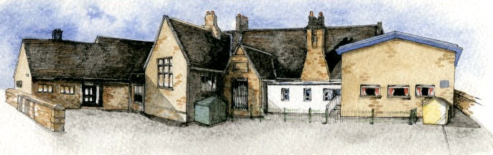

We want our school to be a safe
and happy place where we can
play and learn together.

So we promise to:
- Be kind to everybody
- Listen to adults and each other
- Always try our best
- Move sensibly and quietly around school

- Respect school property

Appendix B Rewards and Incentives at Brabin’s Endowed
At our school we believe that a healthy balance should be created between rewards and sanctions. As well as applying strategies to control unacceptable behaviour we believe that the recognition of strengths and achievements is crucial to promoting our aims. We place a great emphasis on praise and reward because this fosters a positive approach to work and creates a motivating climate within the school.

All class teachers will use the following rewards:
- Verbal recognition in front of the class
- Showing work to the rest of the class
- Writing positive comments on work
- Merits
- Sending child to the Headteacher for praise
- A note home from the Head teacher
- Verbal feedback to parents.
- Star of the Week
- Golden Time
- Writer of the Week
- Remarkable Readers
- Share work with other classes
- Ripple of Kindness

Class Rewards and Incentives

Foundation Stage
Foundation Stage class has:
- Stickers
- Certificates
- Maths Magician Award
- Bee proud of your work display

Key Stage 1
Elm class has:
- Stickers
- Superstar Listener
- Tree of Kindness
- Busy Worker Award

Key Stage 2
Sycamore class has:
- English Superhero
- Dojo
- Maths Genius
- Incredible work display
Oak Class has:
- Stickers
- Privileges (use of computers, use of library)
- Table points

Whole School:
Weekly, from each class, awarded at Celebration assembly:
- Star of the Week Award and stickers for a child from each class who has worked and achieved well that week.
- Dinner Time Award - Welfare staff to decide who receives these.
- Headteacher Award
- Brabin’s Kindness Award
- Magnificent Mathematician

Whole School Awards Termly and Annually:
We also present a further selection of awards to pupils who have achieved success in various subjects on both a termly and annual basis:
- Remarkable Reader
- Wow Writer
- Merit Award (termly)
- Sports Award (termly)
- KS1 Reader Award (annually)
- KS2 Reader (annually)
- James Berry Courtesy Award (annually)
- Progress Award (annually)
- Creative Writer Award (annually)
- Stem (Science, Technology, Engineering and Maths) Award (annually)
- Star of the Year Award (annually)

Appendix C
Individual class Sanctions:

Willow and Elm (Traffic Light)

- Verbal warning*
- Amber*
- Verbal reminder*
- Red – sent to Headteacher/parents informed

*Golden time chances are taken. Children lose Golden time when 4 or more have been taken (8 maximum)

Sycamore (Y3/4)
- Verbal warning
- Lose some privilege/ Golden Time
- Sent to Headteacher/parents informed

Oak (Y5/6)
- Verbal warning
- Lose some privilege/ Golden Time
- Sent to Headteacher/Parents informed

To ensure consistency, we have levelled the types of behaviour likely to cause concern with appropriate sanctions:
Levels | Behaviours | Sanctions
1 | Persistent:  - Calling out  - Getting out of their place  - Not following simple instructions  - Not completing set work  - Not completing homework | Class sanctions put in place  Completing work at break times if the work has not been done in lessons due to misbehaviour  Loss of golden time
2 | - Repeated Level 1 behaviour within the same day  - Rudeness to others  - Name calling  - Deliberate use of swearing  - Not applying themselves in class | Class sanctions put into place and loss of playtime  Entry into ‘Behaviour Log’ if there is a pattern of unkind behaviour to others/deliberate use of swearing or other behaviours that are causing concern
3 | - Repeated Level 1/2 behaviour within the same day  - Physical violence  - Stealing  - Possession of inappropriate items  - Causing wilful damage to property  - Spitting  - Racial Abuse  - Bullying  - Manipulating others | Entry in ‘Behaviour Log’ – Headteacher informed.  Parents to be informed at  Headteacher’s discretion.  (On a second occasion of same behaviour, a meeting with parents will be arranged)  (See Anti Bullying Policy)

Behaviour Policy 2020 Covid-19 Addendum 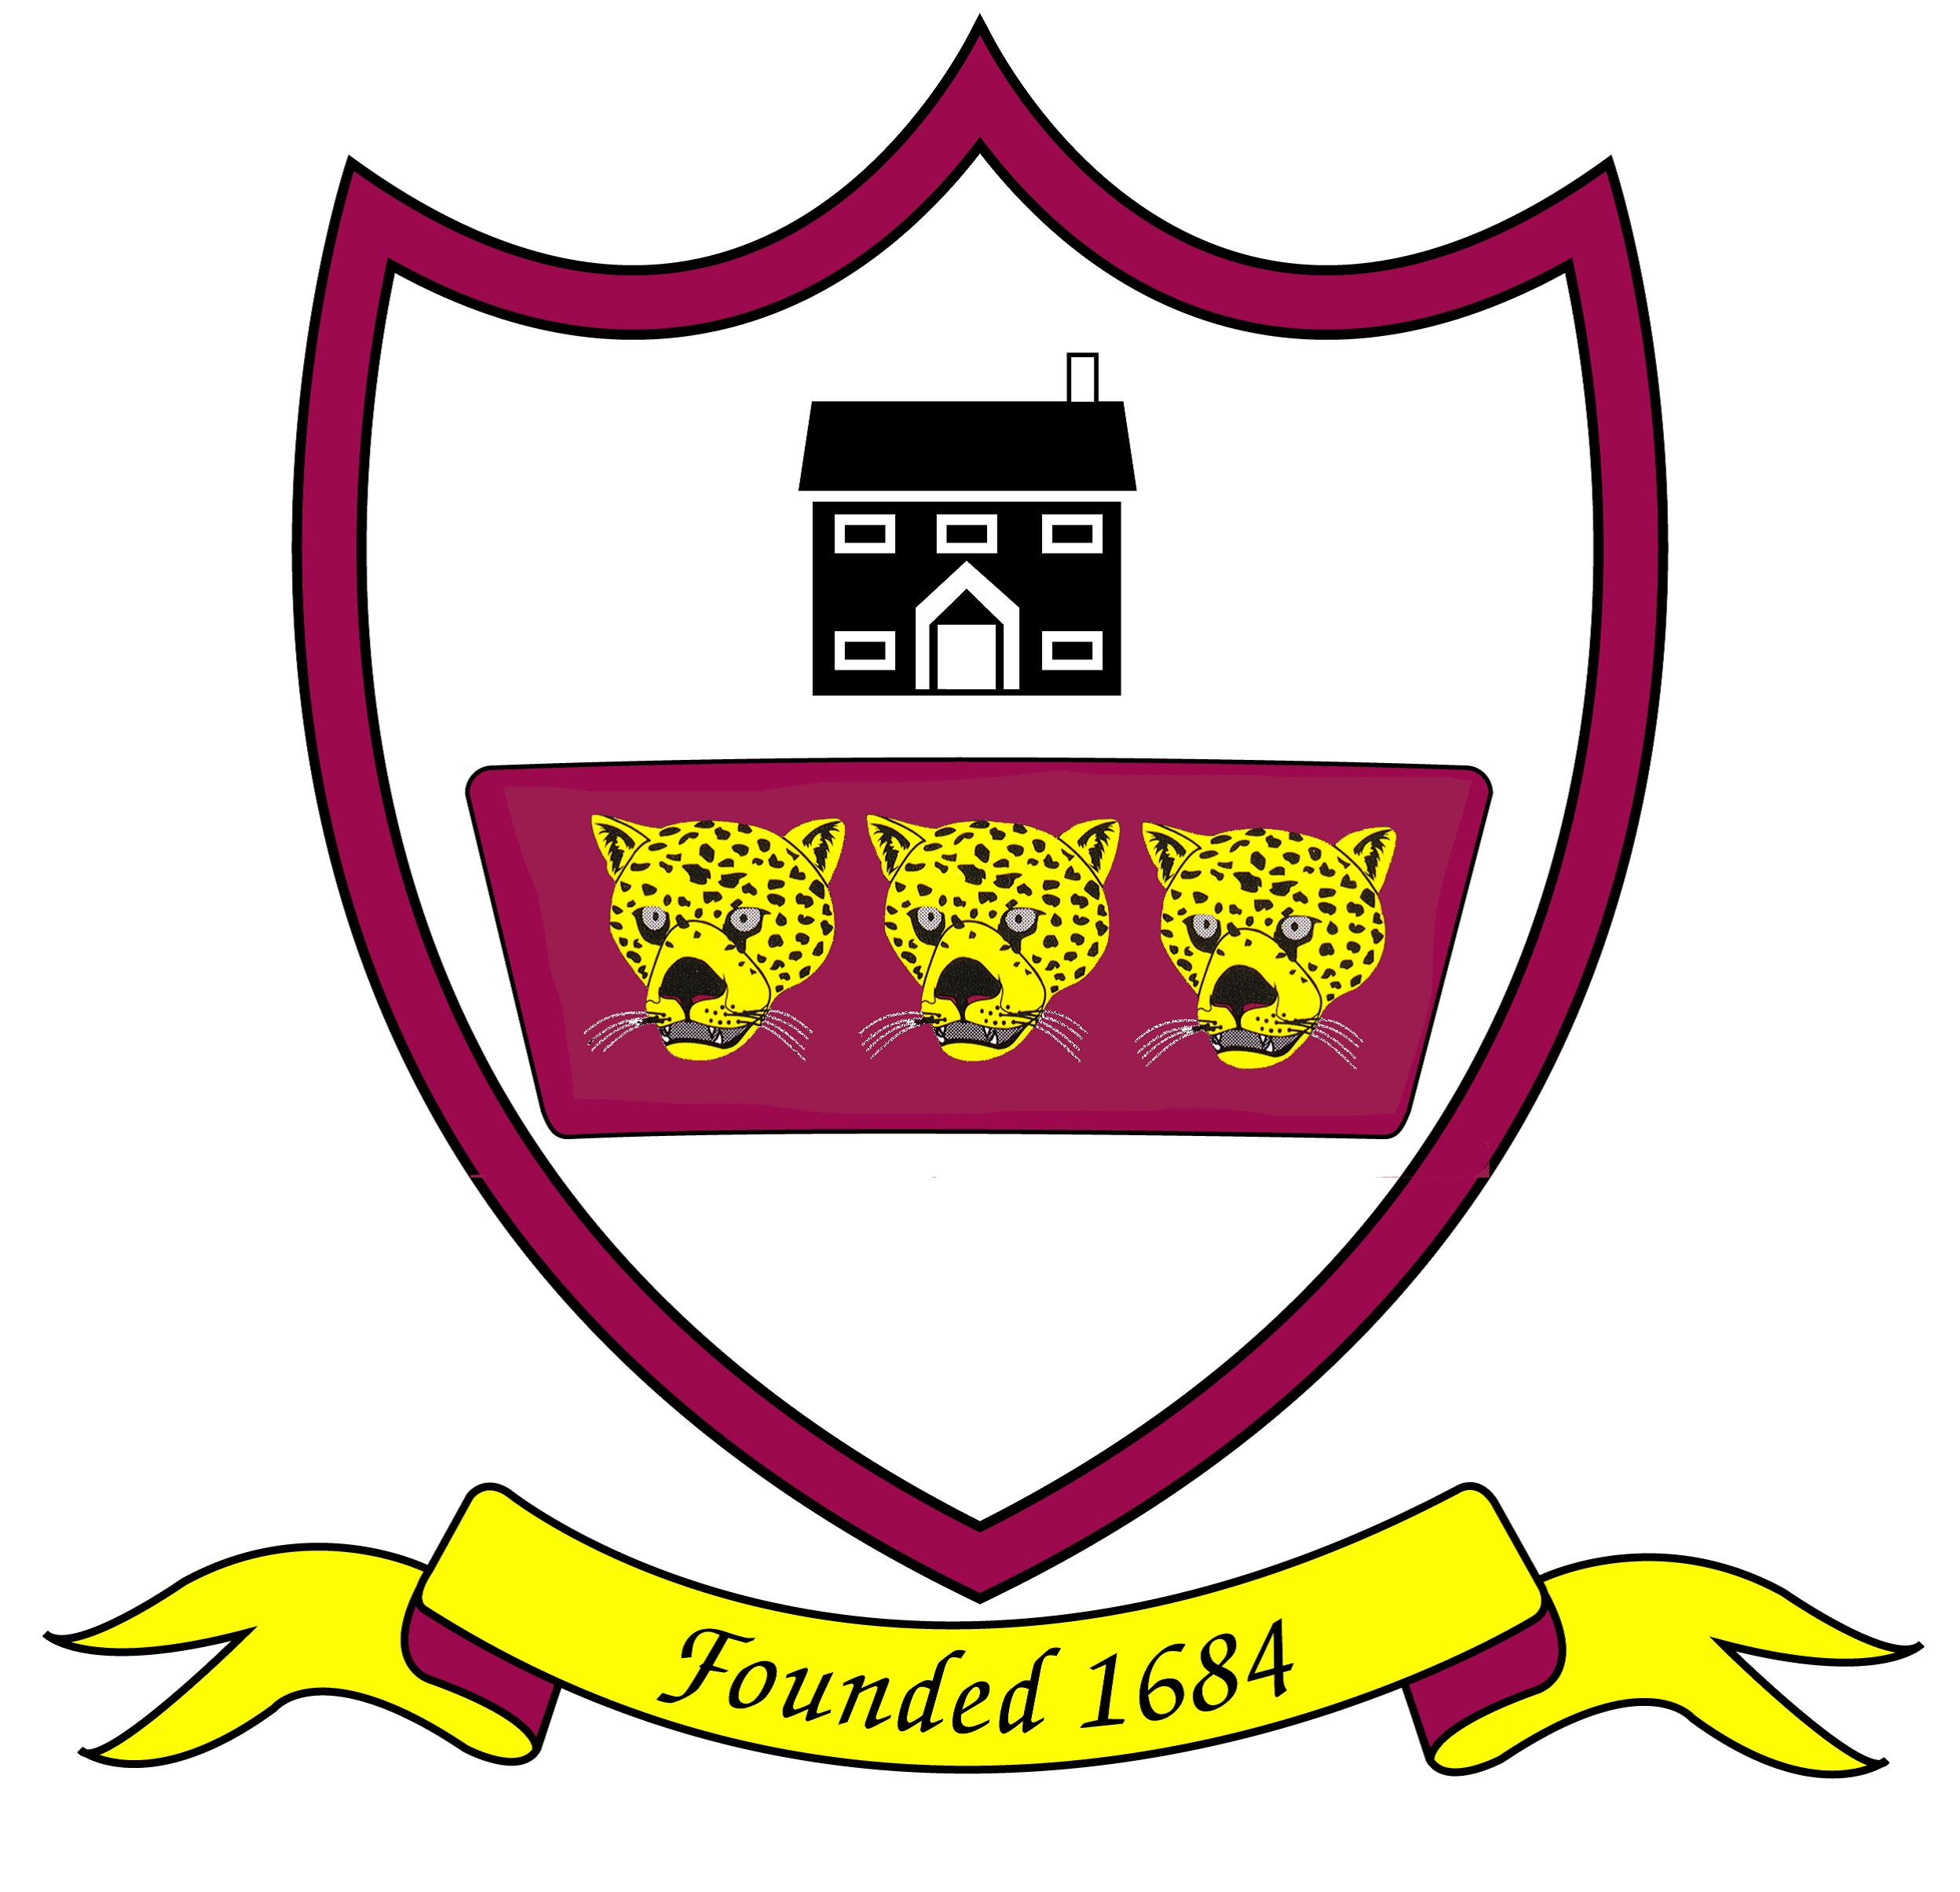
At Brabin’s Endowed Primary School, we aim to maintain a secure, caring and stimulating environment in which children are encouraged to have respect for themselves and each other. Whilst expectations in our Behaviour Policy remain pertinent, it is necessary, in light of the Covid-19 pandemic to make some adjustments for the safety of all pupils and staff. It is to be used in conjunction with, and read alongside, the Behaviour Policy and Anti-Bullying Policy. These adjustments are set out below:
Arrivals, Departures and Moving round the school.
Children will arrive at the agreed time. Children will enter with their parent/carer and will go straight to their designated area, keeping a 2m distance from any other individual. Reception and Y1/2 pupils will enter school through the Reception class door. KS2 pupils will wait on markers on the playground until directed to enter the school building. Markers on the playground and corridors are in place to support children with social distancing.
At their designated home time, children will leave the building from their stipulated exit. They will leave when their parent has come to collect them, again keeping their distance using the markers on the floors as a guide.
Movement around the school will be limited. When the children leave their classroom to go outside for break, lunch or outdoor learning, they will follow the markers on the floor to ensure they stay 2m from peers and adults.
Children must take responsibility for their own equipment e.g. water bottles and ensure that these are not shared with other pupils.

Hand washing and Hygiene
Children will be expected to follow all hand washing and hygiene routines while in school. Children will wash hands /use antibacterial gel before entering school, after returning from the outside, before and after eating and at regular intervals during the day.
We ask children to follow the ‘catch it, bin it, kill it,’ mantra when in school. If they need to cough or sneeze, they should use a tissue, or, crook of their arm. Children will be reminded not to touch their face while at school.
Should a child refuse to follow these routines, disciplinary procedures and sanctions will be used (see below).

Social Distancing
Children who are old enough will be expected to socially distance from their peers and adults in school and on the playground/field at all times. When children enter their bubble, they will be expected to go straight to their table and nowhere else in the room. Children will put their hand up if they need an adult’s support; they will not get out of their seats.

Teachers will ensure that pupils, wherever possible, adhere to social distancing measures. Where older pupils are not complying, the usual disciplinary procedures and sanctions will be used (see below).
We understand socially distancing may be more difficult for younger children They will be encouraged, wherever possible, to keep a distance from peers and adults, however, we understand this may not always be possible.

Toilets
There will be a number of occasions in the school day when the children will have the opportunity to use the toilet. When a child has finished in the toilet, hand washing is compulsory.

Break times
Children will have a designated place to play during break times. Children will be expected to remain socially distant from both peers and adults during play and break times. Children must stay in their designated area at all times.
Rewards
Teachers and Teaching Assistants welcome opportunities to praise individuals for excellent work, a positive attitude or good behaviour; recognition will be forthcoming if these are brought to their attention. Above all praise and encouragement should be used as much as possible. Walking through school to show work to the Head Teacher or other adult for acknowledgement and praise during this time will not be permitted. However, Mrs Wallace will share weekly awards at a social distance.

Behaviour in school
If a child’s behaviour is deemed high risk, for example, refusing to adhere to safety measures, such as hand washing, social distancing, remaining in their bubbles or, deliberate behaviours that put themselves or others at risk, such as spitting or deliberately coughing at people, the following sanctions and disciplinary procedures could be used:
- Conversation(s) with pupil(s) which could include a verbal warning, moving seats if logistically possible and other behaviour management strategies in line with our current behaviour policy.
- Once all appropriate behaviour management strategies have been exhausted, contact should be made with pupil’s parent/carer.
- If the health and safety of other pupils and staff members are put at risk by the pupils not adhering to social distancing measures, then the parent/carer will be expected to collect the pupil and a fixed term exclusion will be applied in line with exclusion guidance.

Pupils with Special Educational Needs

Brabin’s Endowed School acknowledges that children will have had a range of different experiences during the lockdown period which may have an impact on their behaviour upon return to school. Some may present with frustration as a result of being isolated from friends or, having missed a significant event or experience; e.g. exams, school trip, etc. Others may have experienced bereavement or another traumatic episode. For many, the process of re-engagement with learning and the school community, under unusual circumstances, may require some additional input and encouragement.

As a result of these varied experiences children may present with behaviour that is not typical. This may include;
- Anxiety; lack of confidence
- Challenging behaviour; fight or flight response
- Anger; shouting, crying
- Hyperactivity and difficulties maintaining attention

For some children, including those with attachment concerns, or, SEN, (especially those with autism) the change in routines and lack of familiarity will require additional adjustment.

The school recognises that certain behaviours could be a sign that, for some individual children, there is an unfulfilled need and that the behaviour is communicating that there is a problem. The school will undertake an individual risk assessment for the child and take reasonable actions to make the necessary adjustments in a bid to reduce the stimulus that may be triggering the challenging response.

Children with SEN are recognised as being particularly vulnerable and, therefore, have an urgent need to be re-integrated back into school as soon as reasonably possible. School will work closely with parents to implement supportive strategies that will inform an appropriate response. If necessary, the school will seek external support from other agencies such as Educational Psychologists or Early Help.

Pupil’s working from home.
If interacting with other pupils or staff online, students should always be kind and respectful to each other and respectful towards staff, remembering at all times that that staff.
Students should never attempt to contact staff via social media or make comments about staff on social media platforms. Any inappropriate comments to staff online, via Seesaw, or any other platform will be taken very seriously. This is also the case of for any online bullying towards other pupils or peer-on-peer abuse that is disclosed to the school during this time.

