What’s been happening in the classrooms….
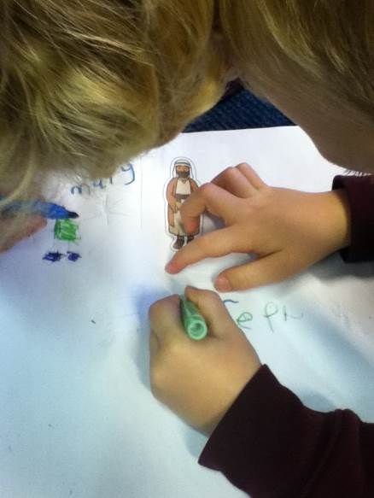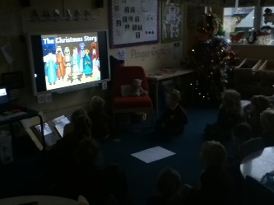Reception Class In RE, we have been learning all about ‘The Christmas Story’ and what happens during each part. The children worked in pairs to retell the story, using their own ideas to add pictures and words to the story.
Izabelle – “We need to put Mary next to Joseph.”
Thomas – “I will write Mary next to my picture.”
Aurora- “I will cut out Angel Gabriel.”

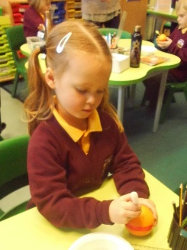Y1/2 – Elm Class Today Rev Fiona visited school and talked to the children about the Christingle. All of the children made their own and learnt about the meaning behind each part.

Mia - The orange represents the world.
Rocco - The sweets are all the good things that God gives us and the candle represents Jesus the light of the world.

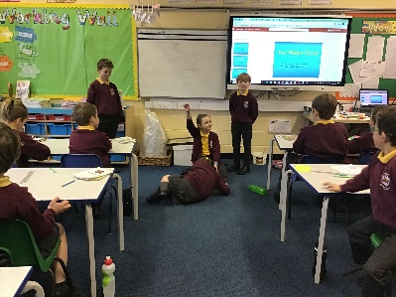Y3/4- Sycamore Class
In Science, Sycamore class have been learning about the water cycle. They produced some short plays to show off their knowledge of the water cycle.

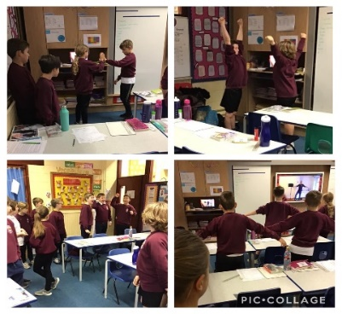Y5/6 – Oak Class
Oak class have had a great time participating in a drama workshop based on ‘The Christmas Carol’. They acted out the different characters and thought about Scrooge’s reasons behind his actions too!

Diary Dates
Tuesday 8th December | Reception visit to Wild Boar Park
Friday 11th December | Christmas Jumper Day - £2 charity donation  KS1 Festive Literacy Show – virtual presentation by The Punctuation Show.
Monday 14th December | Y3/4 Egyptian Day
Wednesday 16th December | Christmas Lunch
Friday 18th December | Talent Show. School closes (normal school times) for Christmas holiday.
Christmas holiday: 21st December 2020 – 1st January 2021
Pupils return to school on Monday 4th January 2021

