What’s been happening in the classrooms….
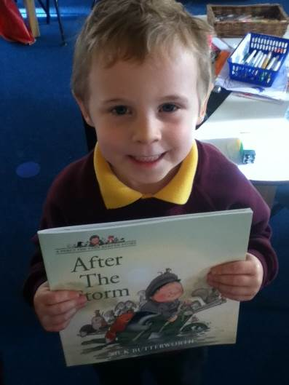
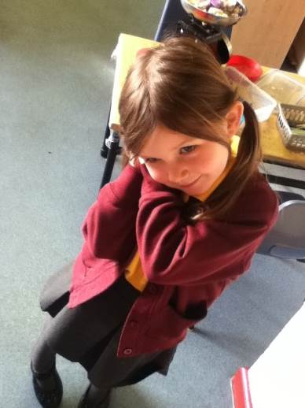
Reception Class As part of our ‘Autumn’ topic we have been reading ‘After the Storm’ by Nick Butterworth. The children love retelling the story using our own actions and vocabulary. We have recorded a video of this story and it is available on our class page of the website.

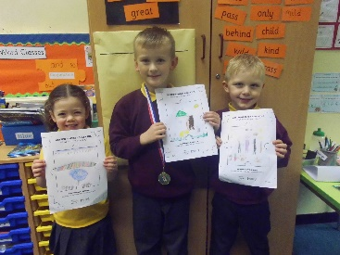
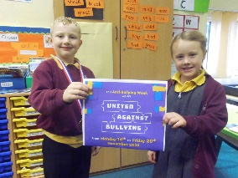
Y1/2 – Elm Class
Last week in Elm Class, the children completed work for Anti-Bullying Week. The theme was 'United Against Bullying' and we all agreed that we are united against it. All pupils decorated a piece of jigsaw to show how unique we are because we celebrate each other's differences.

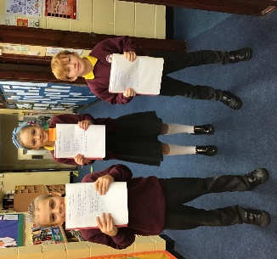
Y3/4- Sycamore Class
In class, we have been writing poetry including limericks and haikus. The children have read some of their poems for you which will be uploaded to the website. We hope you enjoy them!

Y5/6 – Oak Class
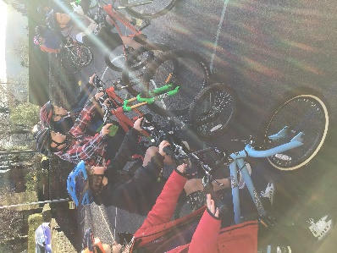
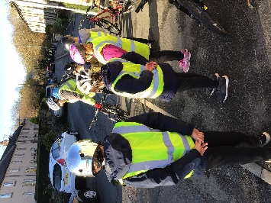
Year 5/6 class have had a fantastic few days participating in The Bikeability Course! They have been learning the essential skills that are needed to cycle safely. The children have had great fun putting these skills into practice around the village.

Diary Dates
Thursday 26th November | Y5/6 Footballs Skills Competition
Monday 30th November | KS2 Christmas Carol Workshops
Friday 11th December | Christmas Jumper Day - £2 charity donation
Monday 14th December | Y3/4 Egyptian Day
Wednesday 16th December | Christmas Lunch
Friday 18th December | Talent Show. School closes (normal school times) for Christmas holiday.
Christmas holiday: 21st December 2020 – 1st January 2021
Pupils return to school on Monday 4th January 2021

