Covid 19  Unfortunately, we have had to postpone some of the extra-curricular clubs and planned school visits in line with current guidelines. The ‘after school club’ can run as normal in order to provide childcare to support family’s needs. Further guidance now states that extra-curricular sport can continue.  All clubs/trips that have been postponed will be re-scheduled as soon as we are able.  We are grateful that the school remains open. As we have now moved back into national lockdown, please ensure that your children stay with you after school and that you leave as soon as you have collected your child/ren. We also ask that the children stay off the drive to avoid other dangers!  Many thanks for your continued support.  In these uncertain times, we want to remind everyone that your child might be eligible for free school meals. Please be assured that this information remains confidential. We also receive extra money in our school budget for each child who qualifies so please take a look at the LCC website, link below, to check if you qualify.  https:// www.lancashire.gov.uk/ childreneducationfamilies/schools/freeschool-meals/ |  | Y5 & Y6 Bikeability- 19th and 20th November 2020  All pupils will need to have their bike in school (in good working order) on these days as well as a helmet. PE Kit should also be worn.  Y5/6 PE Days  PE kit should be worn on Monday and Wednesdays this half term.  Y5/6 Victorian Day – 10th November 2020  Oak class will be learning about life during the period. The work is linked to their English topic where they will study Charles Dicken’s, Oliver Twist.  We look forward to seeing them dressed as Victorians in the morning!  Christmas Raffle – Friends of Brabin’s  This week, each child will be sent home with a raffle ticket book. Fundraising events over recent months have obviously been restricted so we would be extremely grateful for your support!  1st Prize -£100 cash  2nd Prize - £60 Christmas family hamper  Additional prizes include: spirits, wines, chocolates, candles etc.  Please return tickets and money by Monday the 7th of December. The draw will take place on Friday the 11th December 2020.  Please email if you would like to receive additional raffle ticket books. Thank you! |  | 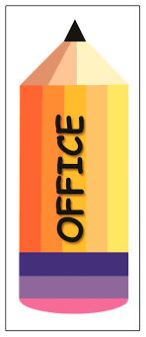  Office  Dinner payments for this half term are due:  38 days: £78.20  Reminder: If you need to amend/book sessions for breakfast or After School Club please contact the office asap.  Brabin’s Kindness Award  The ‘Kindness Award’ has returned! Each Friday, one pupil will be recognised for their kindness towards others. The child will be presented with the special badge that they should wear with pride until the badge is handed over to another pupil the following week. (A spare badge has been purchased to ensure full sanitation can take place!)  On 6th November, Louie was presented with the first award of the school year.  Well done Louie!  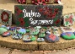  Brabin’s Remembers..  Our pupils have marked this very special event by making individual poppy pebbles which were placed around the village on Friday.  Star of the Week  23rd October  Reception: Izabelle NW  Y3/4: Scarlett U  Y5/6: Finley FW  6th November  Reception: Jack O  Y1/2: Thea S  Y3/4: Isaac M  Y5/6: Emily K  Headteacher Award: Lucas S
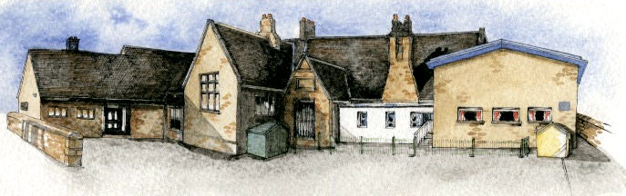
Brabin’s Newsletter
9th November 2020

