Music Enrichment - Brabin’s Beatles Day! 
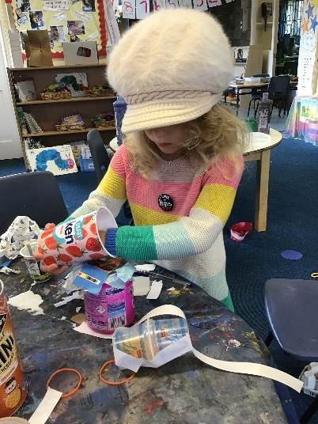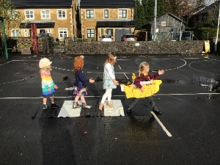Reception Class In Reception the children loved finding out all about the Beatles and performing the song ‘Yellow Submarine’. Each child created their own instrument using junk modelling to play whilst singing the song, instrument’s included guitars and drums. They used a piece of artwork as stimulus for discussion and the children used this to create their own piece using different colours.
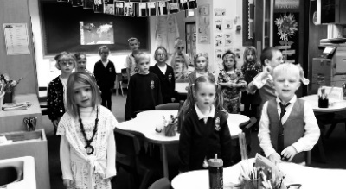Y1/2 – Elm Class
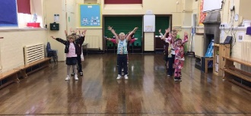The children had lots of fun on Beatles Day and covered a range of subjects. They learnt and performed the first part of the song 'Help' which they then suggested moves for to create a dance. They used their research skills to find key facts about The Beatles to create a timeline of their lives. They used their
artistic skills to design a cover for the
song Octopus's Garden.
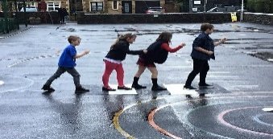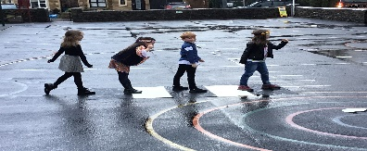Y3/4- Sycamore Class

During Beatles day, Sycamore class looked at how to budget
for a concert in Maths, enjoyed learning about the history of the Beatles and focused on the performance of Twist and Shout. They learnt how to sing in a round, sing songs with different parts and backing vocals as well as learning a dance routine.

Y5/6 – Oak Class
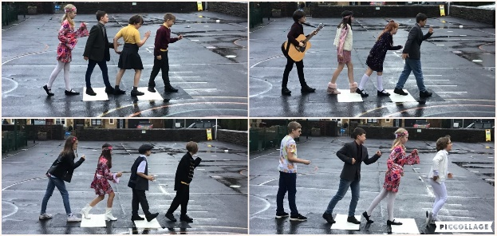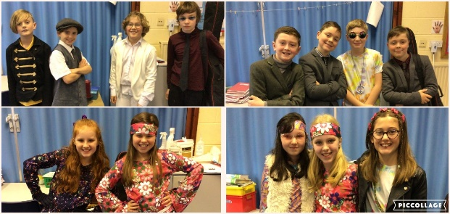
The children enjoyed looking at the history of the famous band The Beatles. The children listened to many songs and even learned to sing All You Need is Love and Let it Be! The children showed amazing confidence, especially the soloists in Oak Class! What a wonderful day! Check out our brilliant costumes too – Wow!

Diary Dates
Tuesday 10th November 2020 | Y5/6 Victorian Day
Wednesday 11th November | Y2 Mini Skills Competition – separate letter
19th November | Y5/6 Rugby Skills Competition
19th/20th November | Y5/6 Bikeability Course
Thursday 26th November | Y5/6 Footballs Skills Competition
Friday 11th December | Christmas Jumper Day - £2 charity donation
Monday 14th December | Y3/4 Egyptian Day

