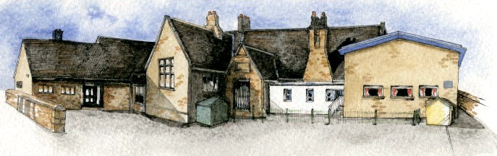

Key Learning Overview;-

Science: the children will be learning about the states of matter and water cycle.

History: the children will be learning about a number of ancient civilisations before focussing on the Ancient Egyptians.

Music: the children will be taught to read some staff notation and play some tuned and untuned instruments and practise for a performance.

Authentic Learning Opportunity: The children will prepare for a musical performance.

Writing Opportunities- we will write: a story based on Charlotte’s Web, some poems with structure (haiku, limericks and kennings) and write information booklets about Egypt.

**BRABIN’S ENDOWED PRIMARY SCHOOL**

**Class: Sycamore Year 3/4 Term: Autumn 2 Cycle B Curriculum Unit – Ancient Egypt**

* Be Curious: engage in first-hand experiences and experience contrasts between periods of history.
* Be Knowledgeable: nurture a thirst for knowledge and apply cross -curricular skills
* Be Adventurous: develop problem solving skills.
* Be Ambitious: develop a growth mindset.
* Be Creative: develop creative thinking skills and question why
* Be Collaborative: working as a team
* Be Reflective: listen to and act on advice
* Be Positive: develop self-esteem and manage ones behaviour.
* A picture containing food, game

  Description automatically generated
* Is it solid, liquid or gas?
* What features do they each have?
* What would it be like if you could shrink and go inside a solid, liquid or gas?
* What happens if a liquid is placed into a different container?
* How can we change water into a solid, liquid and a gas? Can you change it back again?
* What happens if you change the temperature?
* Where does all the rain come from? Where does all the rain go?
* What happens when you heat water?
* How are clouds formed?
* How do humans affect the water cycle?
* What is global warming and how is it affecting water around the world?
* How can we reduce our carbon footprint? / How can we save energy**?**
* Why do we learn about the Egyptians from 2-300 years ago?
* Where will find treasures of Ancient Egypt?
* What secrets of Ancient Egypt did the pyramids reveal?
* What was life like for men and women in Ancient Egypt?
* A building with a mountain in the background

  Description automatically generated

Class Novel, key texts and extracts-

Charlotte’s Webb, The Mousehole Cat, The Waterhorse, Information booklets from around the world, Water Dance poem, Haiku and Kennings poems.

**Curriculum Shapers**

**Key Questions**