What we’ve been learning in school:
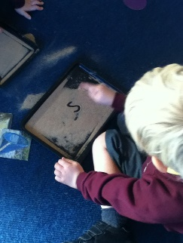
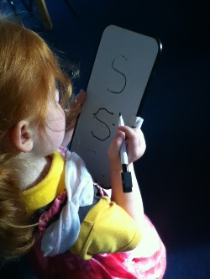
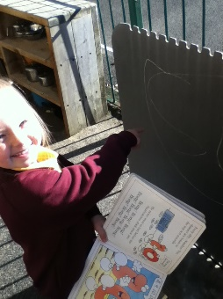
Reception Class- Willow Class
In Phonics, the children have loved learning the sound ‘s’. They have been exploring the classroom to find lots of objects beginning with s. The children have been practising forming this letter in the sand, on whiteboards, using chalk outside and ‘s’ them on big pieces of paper.
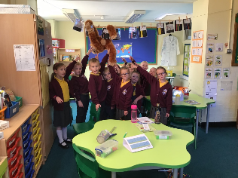
Y1/2 – Elm Class In Elm Class this week, the children were shocked to see the mess one surprise visitor made - an orang-utan! The children are now determined to find out as much as they can about them.

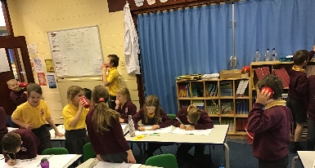
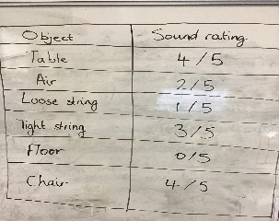
Y3/4- Sycamore Class The children have been experimenting with sound this week in Sycamore class. They have been finding out if sound travels faster through solids, liquids or gases.

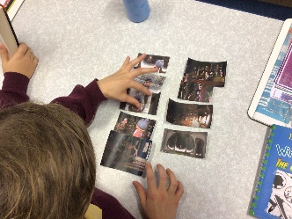
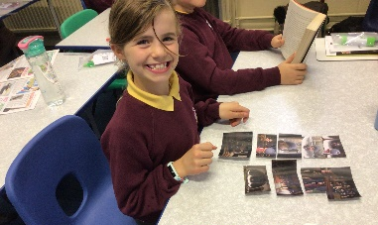
Y5/6 – Oak Class In English, the class have been looking at another suspense story. The children have loved watching the story of Alma – a girl that gets trapped inside a doll! They can’t get enough! Here are some pictures from our English lesson where they ordered the story – ready to write their own versions!

Primary and Secondary School Admissions for
September 2021
Apply for a school place online at:
https://www.lancashire.gov.uk/children-education-families/schools/apply-for-a-school-place/

Closing date for applications: 31 October 2020 for secondary 15 January 2021 for primary

Half term Holiday: Monday 26th October 2020 – Friday 30th October 2020
Inset Day: Monday 2nd November 2020
Pupils return to school on Tuesday 3rd November 2020

---------------------------------------------------------------------------------------------------------------
Advance notice: Christmas Jumper Day – 11th December 2020!! 