Welcome to Brabin’s
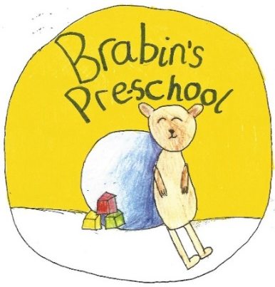
Pre-School

Brabin’s Endowed Primary School
Longridge Road
Chipping
PR3 2QD
01995 61596
Email: head@brabins.lancs.sch.uk
Mission Statement
Brabin’s Pre-School will lay the foundations for learning – learning that will be constructive, yet, fun.
Working together is the key to success – key workers, parents and the individual children will come together to talk and look to the future. This will allow us to record progress, discuss interests and plan for the next steps.
All activities will be considered, and, if required, adapted to meet the needs of the individual child, allowing them to become confident and happy learners.

Welcome to Brabin’s Pre-School

We are delighted to welcome you to our new, exciting venture – Brabin’s Pre-School.
The Pre-School will open its doors for the very first time on 2nd September 2020 to a group of children, aged 2-4 years old.
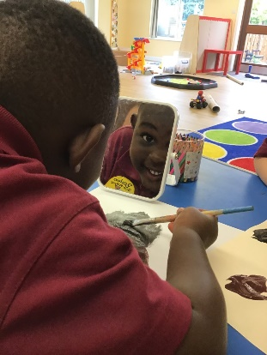
The group will be based in an area of the school that has been purposely designed and developed to meet the needs of Pre-School children.

This welcome pack will hopefully help you and your child settle in at Brabin’s Pre-School. We would like to support you as much as possible to make this an enjoyable experience for you and your family. We hope you find this pack useful. If there is anything left unanswered, please do not hesitate to ask a member of staff or email: head@brabins.lancs.sch.uk

Philosophy
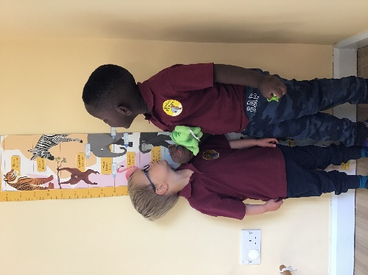
The overriding philosophy of Brabin’s Pre-School is to build on what the children already know and can do. From this secure basis, the children will flourish with security and confidence.
Our trained staff will offer high quality activities designed to stimulate the children, which will, in turn, ignite and extend their learning and development.
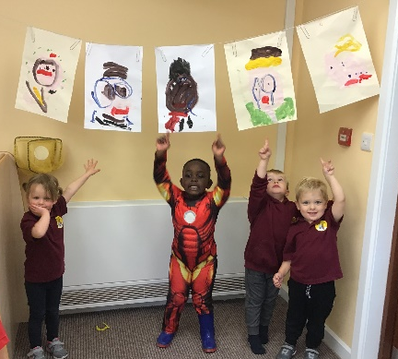
Brabin’s Pre-School will follow the Early Years Foundation Stage (EYFS) framework and this will be delivered by committed and enthusiastic practitioners, who have a thorough understanding of how young people learn. All of this is to take place in a ‘can do’, positive environment.
Overall, the aim of Brabin’s Pre-School is to ensure that each child is happy and secure and, with this foundation, he/she will develop into a young person who enjoys learning.

Staff
Miss Megan Strickland will be the Key Person with a second member of staff from the Brabin’s team supporting learning in the Pre-School.
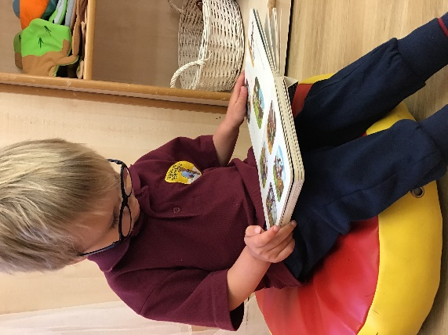
All staff will work closely with parents as communication is key to consistency and progress.
All staff within the setting hold an enhanced DBS, have benefited from updated Safeguarding training and hold a first aid certificate.
The staffing ratio in the nursery is as follows:
2-3 years: 1 carer per 4 children
3-5 years: 1 carer per 8 children

Transition into Reception Class
The children will have the opportunity to work with Miss Doxey (EYFS Teacher at Brabin’s) and the Reception Class children through planned weekly sessions. These are designed to aid a smooth transition into reception class, build strong relationships and to offer enrichment and further quality learning experiences. Sessions will include: Forest Schools, phonics and story time.
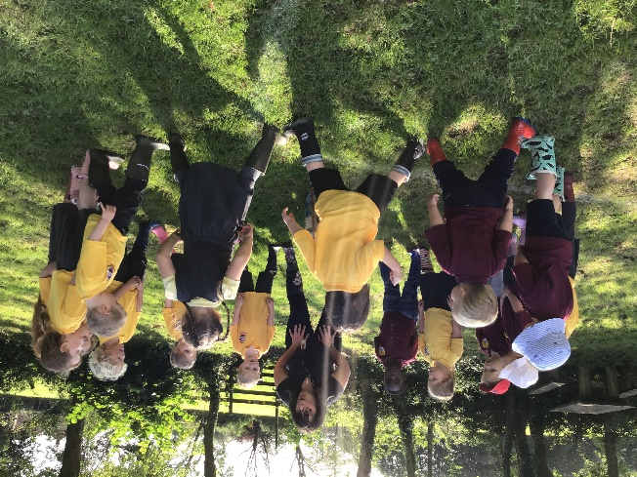

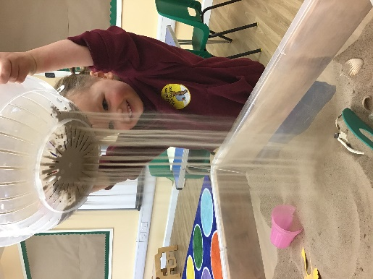
Early Years Foundation Stage (EYFS)
Children develop and learn in different ways and at different rates and all areas of learning and development are equally important and inter-connected. Your child will have a ‘Learning Journey’ file to record and track all of these precious moments.
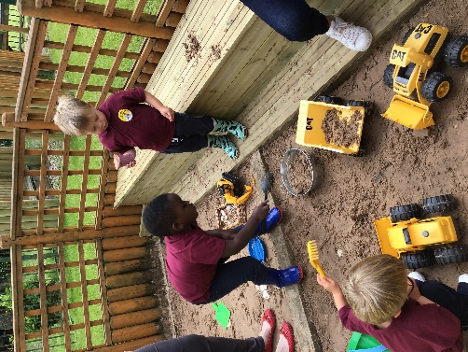
The ‘characteristics of effective learning’ are observed and fostered to support your child’s development and daily diaries will be sent home. You will read about all of the anecdotes, comical sayings and adventures; these will be written down for you to cherish for a lifetime.

The EYFS curriculum is based on seven areas of learning:
Personal, Social and Emotional Development
Communication and Language
Physical Development
Literacy
Mathematics
Understanding the World
Expressive Arts and Design
Prime Areas
Personal, Social and Emotional Development: Self -confidence and self- awareness, Managing feelings and behaviour and Making relationships.
Physical Development: Moving and Handling and Health and Self Care.
Communication and Language: Listening and attention, Speaking and Understanding.
Specific Areas
Literacy: Reading and Writing.
Mathematics: Number and Shape, Space and Measures.
Understanding of the world: People and Communities, The World and Technology.
Expressive Art & Design: Exploring and using media and materials and Being Imaginative.

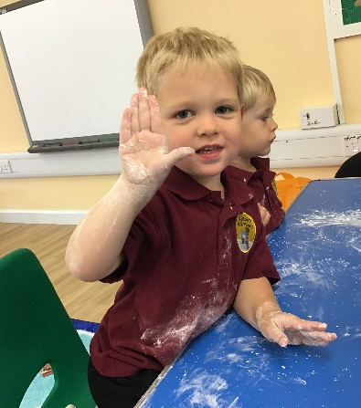
Pre-School Session Times
Morning session: 8.55am – 11.55am
Lunch session: 11.55am-12.15 pm
Afternoon: session: 12.15pm- 3.15pm
*Please see booking form for session/lunch prices
We are open for 38 weeks of the year.
Lunchtime
The children will join Reception Class for lunch. The school kitchen will provide meals for Pre-School pupils (£2.30). The children can eat in the school dining hall and enjoy this as a social occasion.

Settling In Sessions
It is our aim to ensure every child’s start at Pre-School is calm, smooth and enjoyable. We have qualified staff in place to ensure we are able to tailor settling in times to meet the needs of individual children and families. We offer settling in sessions where parents can stay with their child to ensure they are well prepared for Pre-School. Please arrange, via our school office.

Clothing
Pre-School uniform will consist of a logo polo t-shirt and hooded jumper. These are available to purchase at Mary Frances, Longridge. The children will enjoy lots of outdoor learning opportunities so we ask that they wear comfortable jogging bottoms and trainers. If appropriate, please supply nappies.
We request that additional clothing be brought into school on Forest School Days as well as for other planned sessions.
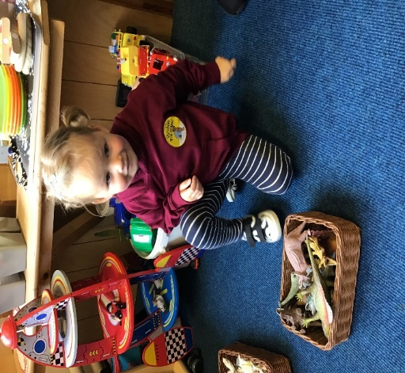
An essential component of educational play is that children are able to enjoy art and craft activities; it is inevitable that children will transfer some of these materials onto themselves and their clothing. We will attempt, whenever possible, to purchase glue, paints etc. that are washable but this might not always be the case!

Parent/Carer Involvement
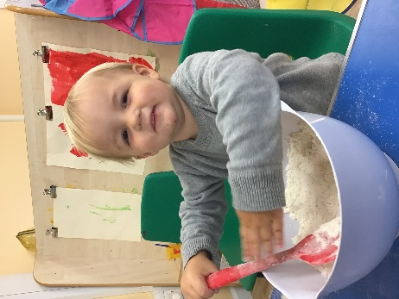
We recognise, and support, that parents are their child’s first and most important educators. To recognise this, our aim is to develop an honest, open and supportive relationship with you which complements life at home. Staff are always available to discuss your child and their development.
Communication:
- Key Person. Your child will be allocated a key person as this will enable you to have a direct member of staff to talk to, ask any questions, or, raise concerns that you may have.
- Newsletters. These regular newsletters will keep parents updated regarding matters relating to Pre-School together with plans and social events.
- Parent Questionnaires. We will invite parents, on annual basis, to give their honest opinion about the service we provide and an opportunity to share their comments and ideas.
- Fundraising and social events.
- Sharing of your child’s Learning Journey and daily diary

Personal Property
Children should not bring sweets or valuables to nursery as we cannot be held responsible for any personal belongings being lost or damaged.

