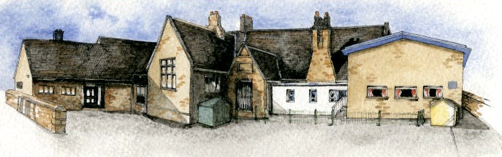

**Class Novel, key texts and extracts-**

The Journey by Aaron Becker

Collection of books by Oliver Jeffers – Lost and Found, Here We Are, Up and Away, Stuck etc

Books and internet pages about animals and the hot and cold places of the world.

**Key Learning Overview;-**

**Science**- Children will **i**dentify and name a variety of common animals including fish, amphibians, reptiles, birds and mammals. They will describe and compare the structure of a variety of common animals.

**Geography-** Children will learn about the seven continents of the world. They will use globes and atlases to locate the hot and cold places of the world (the Polar Regions and countries along the equator). They will also learn the names of the different animals found in these places.

**Art-** Children will make observational drawings of penguins from images. They will use their drawings as inspiration to create digital images and a penguin using clay.

**Computing –** Children will collect and sort images of animals using a search engine. They will learn to save their work.



Class: Elm Class Year 1/2 Term: Autumn 2020

**Curriculum Unit – The Hot and Cold Places of the World**

**Writing Opportunities**-

We will write:

* character profiles and our own story based on the book Lost and Found by Oliver Jeffers
* non-chronological reports of animals
* descriptions of Antarctica

Be Curious: Develop an appreciation of and responsibility for the environment. Experience contrasts (polluted/unspoilt, light/dark, hot/cold)

Be Knowledgeable: Develop subject specific vocabulary. Make the links between the work in science and geography, looking at animals and where they live.

Be Adventurous: Work practically

Be Ambitious: Develop responsibility for one’s own learning

Be Creative: Apply new skills to new situations. Ask questions to find out about the different countries being studied?

Be Collaborative: Work as a team using maps and globes to locate the continents of the world

Be Reflective: Identify and use one's aptitudes and interests as a vehicle for learning

Be Positive:

* What do we mean by the hot/cold places of the world?
* Where are the hot/cold places in the world located?
* What is the weather like in the hot places of the world (near the Equator)?
* What is the weather like near the cold places of the world (North or South Pole)?
* How is the weather at the Equator/Poles different from the weather in our country?
* What are some of the most common animal classes?
* What do animals eat?
* What sorts of animals live in that hot/cold place?
* What sorts of plants grow in that hot/cold place?
* What would it be like to live in that hot/cold place?

**Curriculum Shapers**

**Key Questions**