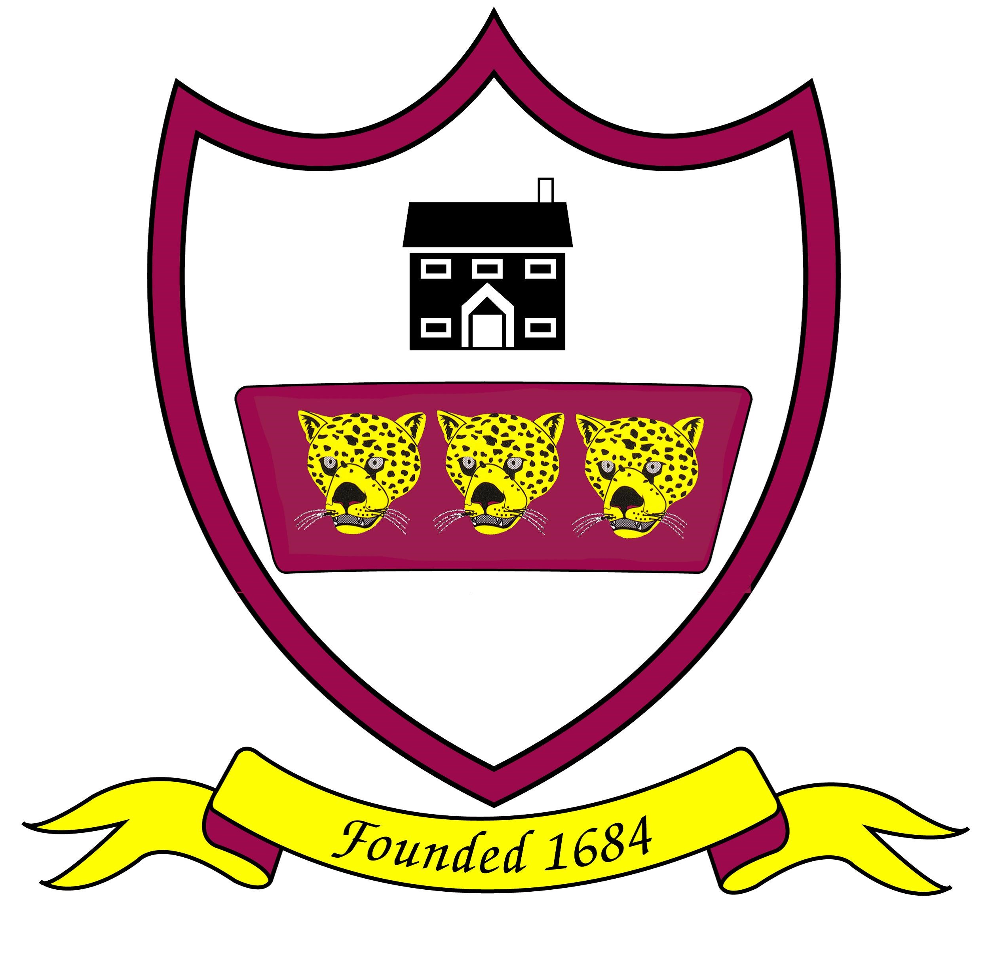
Brabin’s Endowed Primary School
Re-Opening Plan September 2020

School will reopen to all pupils from Wednesday 2nd September 2020.

Background:
The government has issued guidance to schools for a full re-opening from September 2020. Within the guidance, it is acknowledged that unlike older children and adults, early years and primary age children cannot be expected to remain 2 metres apart from each other and staff. Where possible and practical we will try to maintain social distancing between children and between staff and children. However, where social distancing cannot be maintained the following safeguarding measures are in place:

- minimising contact with individuals who are unwell by ensuring that those who have coronavirus symptoms, or who have someone in their household with symptoms, do not attend school
- cleaning hands more often than usual - wash hands thoroughly for 20 seconds with running water and soap and dry them thoroughly, or, use sanitiser ensuring that all parts of the hands are cleansed.
- ensuring good respiratory hygiene - promote the ‘catch it, bin it, kill it’ approach
- cleaning frequently touched surfaces often, using standard products, such as detergents and bleach
- minimising contact and mixing by altering, as much as possible, the environment (e.g. classroom layout) and timetables (e.g. staggered break times)

Rationale for Class Groupings and Classroom Location:
Throughout the government guidance, there is an over-arching principle of reducing the number of contacts between children and staff. This is to be achieved by keeping groups small and separate and by maintaining distance between individuals.

The main building and class sizes at Brabin’s are suitable for a full re-opening with certain measures in place, such as KS2 having dinner in their classrooms as well as staggered breaks, to ensure that contact across the school is reduced.

Preparation for Returning to school: If you would like to share any particular concern, please contact your child’s class teacher, or, Headteacher via email. Following any long break, the re-establishing of routines can be problematic but introducing standardised bedtimes, for example, will help your child a great deal with their early starts in September.

Uniform:
Children will be expected to attend school in full school uniform. If possible, please wash clothing daily.
Presently, the guidance from the DfE is not to allow children to change into their PE kits in school but to arrive wearing them for the day. This being the case, it is important that children wear the correct PE kit as this will be their uniform for 2 full days a week. You will be informed of your child’s days for PE in the first newsletter, Tuesday 2nd September. (There will be no PE in the first week of 3 days).
PE Kit List
- Plain white/ white t-shirt with school crest
- Plain black shorts or plain black jogging bottoms
- School sweatshirt or cardigan
- Trainers
All children should bring a waterproof coat each day regardless of the weather. This is to enable learning to take place outdoors on a regular basis. It can become chilly at playtimes and particularly when the children are working outside for any length of time.

Communication between School & Parents:
The provision of the School Reopening Plan enables parents to know the safety measures in place and what the provision will look like during the full return to school.

From September 2020, parents will still not be able to access the school building without a prior appointment. In the first instance, communication should be via telephone conversation, or, email. If you do require a face-to-face appointment, this will need to be arranged via the school office.

To facilitate successful communication, please ensure all telephone and email addresses are up-to-date. Therefore, the completion and return of the pupil data forms at the start of term is essential. Please also ensure that the correct email is updated on ParentPay.

Class Locations and Learning Resources:
The children will be placed in class ’bubbles’ and work in the usual classrooms. Each child will only mix with the adults and children in their bubble throughout the day and will not be able play with other children on the playground as the playground will be zoned and playtimes staggered.

Due to the nature of early years we will encourage social distancing but cannot guarantee this. We will mitigate the risk of infection by reducing the amount of equipment/surfaces used. To supplement this, there will be continuous cleaning, regular hand washing and good respiratory hygiene (using paper tissues- catch it, bin it, kill it).

Each child will be allocated a specific learning table/tray where they will be based during the learning day (depending on the year group). Tables will be arranged to ensure the maximum amount of space between children in line with government guidelines. Individual resources will be provided to limit the amount of shared equipment. Children will be expected to bring only limited resources into school, including their reading book and relevant home learning. Pencil cases are not permitted.

Whilst there will be designated times for toileting, the children will have full access to the toilets throughout the day with a limit of two children at any one time (per bathroom) as long as they are from the same bubble. This will be co-ordinated by staff and should children need to wait to use the toilet, as another child is using it, there will be a designated waiting area marked out.

Pupils in KS2 will eat their lunch in classrooms during the Autumn term. Children from Reception, years one and two will continue to eat their lunch in the dining hall. School dinners will be provided as normal. If your child has a packed lunch, they should bring their lunch box into their classroom at the start of the day.

Curriculum:
All class teachers have a clear knowledge of the levels of attainment for the children in their new classes up to March 2020. During the first two weeks, each teacher will carry out learning assessments to identify needs and any gaps in learning. Teaching time in the first term will prioritise these gaps in knowledge and skills. Individual Education Plans and Intervention programmes will be provided for those with specific learning needs.

Initially, on our return to school, there will also be an emphasis on PSHE. Teachers will identify and respond to the differing social and emotional needs of the children. We will provide the children with opportunities to talk about and discuss their anxieties and provide practical lessons for staying safe e.g. washing hands and safe play. There will also be lots of opportunities to renew and develop friendships with the children in their class.

Home Learning:
If for any reason an individual child, or, class needs to self-isolate, learning will continue to be provided through the Seesaw App. Teachers will be available through the Seesaw App and email to support parents with home learning should the need arise. We will also provide the opportunity for pupils to access some lessons through Zoom.
The advice remains to limit the number of items brought to/from school and it is our intention to promote the home learning page as a ‘paper less’ homework facility. Learning tasks will be placed on class pages on the school website including spelling lists and My Maths tasks. Work can be uploaded to the class Seesaw App rather than returned to school in books.

Reading books are now able to be taken home and these are likely to be the only items that travel between home and school. These books will undergo a 72 hour quarantine before being re-assigned to another child.

Breakfast & After School Club:
Breakfast and After School Clubs will be open from the start of term with children kept within their bubbles in the hall to maintain social distancing. Drop off and pick-up will take place from the Reception Classroom as normal.
Places must be booked so appropriate staffing numbers are in place.

Drop off and Pick Up:
For the Autumn term 2020, start and finish times are slightly altered in order to facilitate a staggered start and finish. This is to ease congestion, limit the amount of queuing required and to ensure that children can wash their hands before the start of the school day. Only one person should drop off/pick up children as this will support social distancing.
If waiting for children, please keep 2m apart and move away from any thoroughfares. Once the children have entered the school yard they should stand on a ‘spot’. There will be a member of staff on the playground to supervise the pupils so parents can leave the site once the children are safely on the playground.
For our new reception pupils, parents are welcome to take their child onto the reception play area as we appreciate that it is important for the children to feel settled during the first few days of starting school. Miss Doxey will be waiting in this area to welcome you and take the children inside.
Drop off and pick up points/times will be as follows:
 | Location | Drop off | Collection
Reception | Reception Play Area | 9:00am | 3:10pm
Key Stage One (Y1/2) | School Playground – Reception door | 8:55am | 3:15pm
Y3/4 | School Playground | 8:50am | 3:20pm
Y5/6 | School Playground | 8.40am | 3.10pm
Children will clean their hands when entering, or, leaving school. There will be a member of staff to supervise and welcome the children.

Sickness:
All illnesses of children should be reported to the main office. This should be done on the first day of illness, via telephone message.

If a child or, staff member has symptoms of Coronavirus they must not come to school. Staff and parents must inform the headteacher and testing should be arranged. School should be contacted immediately.
If a pupil displays symptoms they will not be permitted to remain in school. Their parent will be required to take them home. Where this is not immediately possible, the pupil will be placed in the first aid room until they can be collected (whilst being mindful of individual pupils' needs.)
In the event of a positive test result, the Headteacher will initiate testing/tracing for the member of staff/ children as appropriate in-line with the test and trace recommendations.

- If the person develops symptoms, they should self-isolate for 10 days and arrange a test asap (do not return to school unless the test is negative and you are feeling well enough to attend). If the test is positive other members of the household should self-isolate for 14 days.
- The results of the test to be shared immediately with school
- Following a positive result, all members of the class bubble will be sent home to self-isolate for 14 days. Names of those who have tested positive will not be shared in line with GDPR regulations unless this is essential to protect others.
- If a further member of the bubble becomes ill, they should repeat points 1-3.
- Children and staff can return to the bubble after 10 days isolation (in confirmed cases) or, 14 days if isolating without symptoms.
- Children and staff in test and trace self-isolation who receive a negative result must remain in isolation for the full 14 days.

The learning area assigned to affected bubble will be cleaned and disinfected and left empty until the return of that particular bubble to the school. The school will contact the local health protection team as soon as they have been notified of a positive result. This team may also contact schools directly if they become aware that someone who has tested positive for coronavirus (COVID-19) attended the school – as identified by NHS Test and Trace.

PPE (Personal Protective Equipment):
The government guidance is clear that PPE should only be worn in specific circumstances in school. Staff will only wear it if they have to work closely with a child; for example, administering first aid or intimate care.
PPE will also be worn by any staff member supervising a child who has symptoms of Coronavirus whilst they wait to be collected by a parent.
It is important to note that should a child have an accident, for example on the playground, they will have first aid administered to them as usual (with a staff member wearing PPE.)

Attendance
All children are expected to return to school in-line with the school re-opening plan, including those who were considered to be clinically extremely vulnerable and received a letter advising them to shield. If your child has an on-going medical condition that prevents their return to school, you will need to discuss their care with their health professional before returning to school. In this instance we will work closely with you to carry out an individual risk assessment, as necessary. Please contact Mrs Wallace via email prior to returning to school on, head@brabins.lancs.sch.uk

SEND Pupils:
Our children have a range of needs and we will need to plan accordingly to ensure the wellbeing of specific pupils so that they have a safe and successful return to school. Please contact Mrs Wallace via email for further information or advice.

Lunchtimes & Playtimes:
These will be staggered across the play areas, so a smaller number of pupils are on the playground at any one time. The children will only be able to play with those children in their bubbles and will be in zones on the playground / field and supervised by an adult at all times.
KS2 will eat their lunch in classrooms. School lunches will be brought to the children from the kitchen. Pre-School, Reception and KS1 children will eat in the school dining hall.

Visitors to School:
Only essential visitors to school will be allowed on site. An example of an essential visitor would be a contractor completing the weekly water tests which are statutory and, in not doing them, would potentially affect the health of the school community.
Visiting teachers will also be allowed to support the delivery of a broad and balanced curriculum.

School Policies:
Key school policies such as Behaviour and Safeguarding Policies have been reviewed and amended to address the current restrictions. Updated policies are available on the school website.

The new arrangements for an evacuation of the school premises due to a fire will be communicated to the children whilst a fire drill and a lockdown procedure will be practiced during the first two weeks back in school. This is to ensure the new arrangement is workable and practical.

Review:
The Chair of Governors, in consultation with the Headteacher, will keep the plan under constant review considering changes in government guidance, views of our community, good practice in other settings and by learning from what is a new situation for us all. Any changes will be communicated to parents.

Document Control:

AUTHOR DATE DESCRIPTION |  | VERSION | CHANGE REFERENCE  /Description | Approvers
24th August 2020  Mrs Wallace | V1 |  | First Draft | Governing Body  Staff
10th September 2020 | V2 |  | Updated re staggered times | Governing Body  Staff

