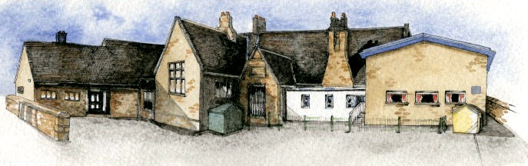

Key Learning Overview;-

Geography- the children will be learning about the three R’s and how humans can impact the world.

Art- the children will be learning how we can use recycled materials to model and create sculptures

Science- the children will be learning all about sound, how we hear and how sound travels.

Authentic outcomes: the children will create some how to guides, explaining how people can reuse household items for useful things that will be published as a ebook.

Writing Opportunities- we will write: a classic narrative poem based on Macavity the Mystery Cat (learnt for a performance), a fairy tale and a newspaper report.

**BRABIN’S ENDOWED PRIMARY SCHOOL**

**Class: Sycamore Year 3/4 Term: Spring 1 2020 Curriculum Unit – Reduce, Reuse, Recycle**

Class Novel, key texts and extracts-

Macavity the Mystery Cat, the Pied Piper of Hamlin, Puss in Boots and other Fairy tales and appropriate newspaper reports from First News.

* What is meant by ‘environment’?
* What do we like/dislike about our environment (classroom, school, home, town, country, world etc)?
* How much waste/rubbish do we all produce?
* What, exactly, is meant by waste/rubbish? Where does all the rubbish go? How does it get there? What are these places like?
* Could more waste be reused or recycled?
* How could we reduce the amount of rubbish we produce in the first place?
* Why should we reduce the amount of rubbish produced?
* How could we persuade others to reduce the amount of waste they produce?
* How can we describe sounds?
* What is the difference between sound and noise?
* How do we hear sounds?
* What happens to a sound the further we get from the source?
* How are sounds created? How do sounds travel?
* How can sounds be changed?
* How can we block or muffle sounds?
* What if there were no sounds?
* What if we didn’t have ears?
* What if all sounds were noisy or all sounds were quiet?

* Be Curious: engage in first-hand experiences and explore concepts such as polluted and unspoilt areas.
* Be Knowledgeable: nurture a thirst for knowledge and apply cross -curricular skills
* Be Adventurous: develop problem solving skills, helping to think how we can help the environment.
* Be Ambitious: seek opportunities.
* Be Creative: develop creative thinking skills and question why.
* Be Collaborative: develop empathy and social skills
* Be Reflective: develop reasoning skills
* Be Positive: develop own opinions.
* A picture containing device

  Description automatically generated

**Curriculum Shapers**

**Key Questions**