Brabin’s Endowed Open Week
Monday 12th October 2020- Friday 16th October 2020
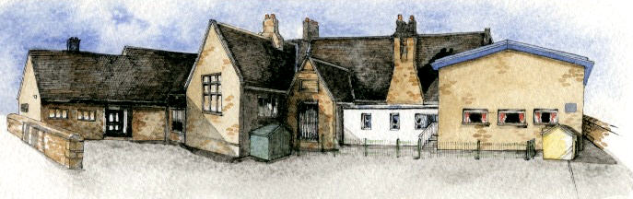
Learning together, memories forever…
At Brabin’s we are more than friends - we love and value one another as part of God’s family. We respect each other and strive to achieve our best when we are learning and in all we do.

“Love one another as I have loved you.”
John 15:12

Virtually Brabin’s!
From Monday 12th October, take a virtual tour of our school. Watch the children share their learning and thoughts of Brabin’s Endowed, with a specially made video uploaded to our school website: www.brabinsendowed.co.uk

Starting Monday 12th October, we are happy to make individual appointments to show prospective children and parents around our school. We will ensure the visits will be compliant with current guidance.
To make an appointment, please ring the school, or, email the headteacher.

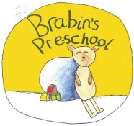
New this year – Brabin’s Pre-School!
If you are looking for Pre-School provision, why not make an appointment to view our exciting new setting?

Brabin’s Endowed School

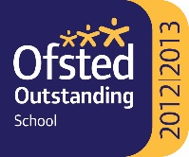
Longridge Road,

Chipping,
Preston
PR3 2QD

Tel: 01995 61596 Email address: head@brabins.lancs.sch.uk
Brabin’s Endowed School Chipping & Brabin’s Pre-School

