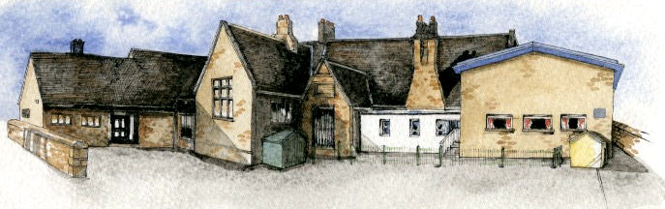

Key LearningOverview;-

**Science**- Through a range of investigations, children will explore falling objects, air resistance, friction and forces that make things begin to move, get faster or slow down.

**History-** Children will study a non-European society that provides contrasts with British history- ‘The Islamic Golden Age’ (900AD). Using enquiry skills, they will study this period in depth and make comparisons with other countries. What was happening in Europe at the time?

**DT** - Children will explore using mechanical systems such as cams, pulleys, gears and motors.They will then design and create their own musical invention.

**Music**- Children will learn about the different groups that make up an orchestra before creating their own musical instrument in DT. They will then play their instruments, focussing on their use of various musical elements e.g changing pitch.

**Art**-Within Computing lessons, children will study Islamic Art through digital media.

Writing Opportunities-we will write:a selection of narrative pieces linked to our novel ‘Clockwork’, explanations focussing on how inventions workand poetry inspired by well-known songs.

**Class: Oak Year 5/6 Term: Autumn 2020Curriculum Unit –Inventors and Inventions**

**BRABIN’S ENDOWED PRIMARY SCHOOL**

Class Novel, key texts and extracts-Novel: ClockworkExtracts of: Hugo Cabret and the Incredible Adventures of Professor Branestawm

**Key Questions**

**Curriculum Shapers**

* Be Curious: invoke a sense of awe and wonder of the Universe
* Be Knowledgeable: develop subject specific language and apply cross-curricular skills
* Be Ambitious: see possibilities and strive for improvement.
* Be Creative: explore alternatives in problem solving situations.
* Be Collaborative: work with others in an interactive process
* Be Positive: listen and respond to advice from peers and adults.
* How do forces affect movement?
* How are forces measured?
* What are levers, pulleys, cams and gears? How are they used?
* How can the above components be used to make a musical instrument?
* What was Baghdad like in 900AD?
* What was the House of Wisdom and who studied there?
* How can Islamic Art be created digitally?
* Year 1/2: Everyday Materials
* Year 3/4: States of Matter
* Year 3/4 :Famous European Scientists
* Year 3/4 Forces:
* compare how things move on different surfaces
* notice that some forces need contact between two objects, but magnetic forces can act at a distance
* observe how magnets attract or repel each other and attract some materials and not others
* compare and group together a variety of everyday materials on the basis of whether they are attracted toa magnet, and identify some magnetic materials
* describe magnets as having two poles
* predict whether two magnets will attract or repel each other, depending on which poles are facing

**Prior Knowledge**

**Key Skills Coverage - Science**

**Knowledge**

* explain that unsupported objects fall towards the Earth because of the force of gravity acting between the Earth and the falling object
* identify the effects of air resistance, water resistance and friction, that act between moving surfaces
* recognise that some mechanisms, including levers, pulleys and gears, allow a smaller force to have a greater effect

**Working Scientifically**

* By carrying out fair tests to determine which designs are the most effective.
* By exploring and investigated each force in action through a range of activitiese.g parachutes and paper boats in water
* By creating/inventing/designing artefacts that use simple levers, pulleys, gears and/or springs and explore their effects.

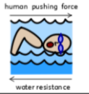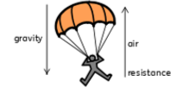

**Key Scientific Skills**

**Key Vocabulary**

**Force**-the pulling or pushing effect that something has on an object **Gravity**- the force which causes objects to fall to the ground **Air resistance**- a force which slows down a moving object or vehicle and opposes the force of gravity**Water resistance**- friction which is created by water and an object moving through it**Friction** –the resistance of motion when one object rubs against another**Mechanisms**- a system of parts working together in a machine**Newtons**- unit used to measure force**Levers**-a basic tool used to lift or pry things open**Pulleys**-a simple machine that makes lifting something easier. A pulley has a wheel or set of wheels with grooves that a rope or chain can be pulled over **Gears**- a part of a machine that causes another part to move because of teeth which connect the two moving parts

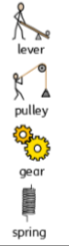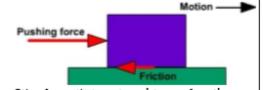

* Year 1/2: A study of events beyond living memory- The Great Fire of London
* Year 1/2: A study of significant people including Christopher Columbus
* Year 1/2: Comparative study-The seaside then and now
* Year1/2: Changes within living memory-
* Year 1/2:Local History- school
* Year 3/4: A theme in British History- the Great Plague
* Year 3/4:A Study of Ancient Egypt
* Year 3/4:Roman Britain
* Year 3/4:Ancient Britain- the Stone Age
* Year 3/4: Local History Study

**Key Skills Coverage - History**

**Prior Knowledge**

**Key Historical**

**HisHil Skills**

**Key Vocabulary**

**Chronology**

* Identify where periods of studied fit into a chronological framework by noting connections and contrasts over time

**Events, People and Changes**

* Establish a narrative connection and trends across periods of study

**Organisation and Communication**

* Understand Historical concepts and use them to make simple connections and draw contrasts.

**Enquiry, Interpretation and Sources**

* Understand how our knowledge of the past is constructed from a range of different sources and different versions of the past often exist and give some reasons for this

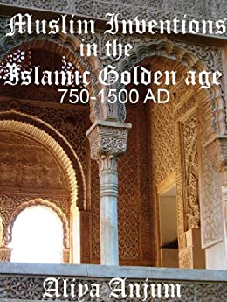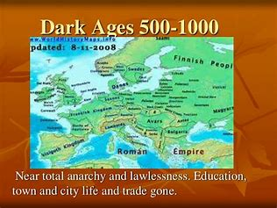

**Baghdad-** the capital city of Iraq and the centre of learning visited by many scholars in the 10th century AD **The House of Wisdom**- also known as the grand library of Baghdad- a centre of learning **Abbasid** – a member of the Abbas family, the ruling Caliphs of Baghdad**Caliph** – spiritual leader of Islam, any of the former Muslim rulers of Baghdad**Dwelling** – a building or place of shelter, living space **Geometric** – a figure formed by points, lines, curves or surfaces, made of circles, rectangles, triangles, etc**Scholar** – someone who has excellent knowledge of a particular subject**Sultan** – ruler of an Islamic country**Anatomy** – the scientific study of an animal or plant, or any of its parts**Arabesque** – a style associated with Islamic or Arabic qualities**Astronomy** – the scientific study of space and the universe

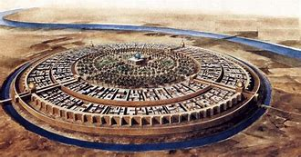

Year 1/2: Friendly Robots (singing and musical patterns/elements)

Year 1/2: Latin Music (performing and listening) Year 1/2: Fire! Fire! (performing and listening) Year 3/4: Rock and Roll (performing and listening) Year 3/4: European Composers (listening and composing) Year 3/4: Iron Man- Marvel Trailers (listening and composing)

**Key Skills Coverage - Music**

**Prior Knowledge**

**Key Vocabulary**

**Key Musical Skills**

**orchestra** – a large group of instruments, usually classical

**ensemble** – all instruments in an orchestra or all voices in a choir, playing at once.

**unison** – playing or singing the same notes simultaneously

**duet** – two vocalists or instruments

**dynamics** – how loud or quiet a piece of music is

**tempo** – speed of a piece

**duration-** length of note

**pitch**- how high or low a sound is

**timbre-** the quality of sound

**texture**- layers of sound

**structure-** the order of a piece

**scale** – successive notes of a key, ascending or descending

**octave** – 8 full tones above the key note. Start and end of a scale

**rest** – moment when a note is not played for a defined length of time                                                                **ostinato**- A short repeated   rhythmic or melodic pattern.

**Listening**

* listen with attention to detail and recall sounds with increasing aural memory

**Performing**

* play and perform in solo and ensemble contexts, using their voices and playing musical instruments with increasing accuracy, fluency, control and expression

**Musical Elements (Revise all briefly through listening process)**

1. Pitch: Identify short phrases and long phrases, prominent melody patterns in a piece of music, Improvise a melodic patterns and melodies.
2. Duration: Perform rhythmic patterns and ostinato, identify a silence in a rhythmic pattern with a gesture, indicate strong and weak beats through movements and recognise a metre.
3. Dynamics: Recognise crescendo, diminuendo *a*ssess the appropriateness of dynamic.
4. Tempo: Identify the differences between fast and slow tempos and identify the tempo of music as fast, moderate, slow, getting faster or getting slower.
5. Timbre: Identify groupings of instruments and recognise the instruments heard in a piece of music.
6. Texture: Understand how the texture might vary in a song.

**Prior Knowledge**

**Key Skills Coverage - DT**

* Year 1/2: Mechanisms-pop ups and simple card levers
* Year 1/2:Mechanisms- axles and wheels
* Year 3/4: Mechanical Systems- levers and linkages

**Key Design Skills**

**Key Vocabulary**

**Technical Knowledge**

* Understand how gears and pulleys can be used to speed up, slow down or change the direction of movement.

**Design- generating ideas**

* Use models, kits and drawings to help formulate
* design ideas. List tools needed before the start of the activity

**Making**

* Select from a range of materials/tools. Use mechanical systems such as cams, pulleys and gears.
* Develop understanding of technical vocabulary and can explain to others

**Evaluating**

* Research and evaluate existing products using ICT/books to compare.
* Discuss how key people have influenced their design.

**Cam**-Specially shaped wheel, or one with a hole off-centre; when it rotates, anything resting on its edge will bob up and down, as in a pull-along toy.

**Pulley**-A grooved wheel over which a rope can run.

**Gears**- a part of a machine that causes another part to move because of teeth which connect the two moving parts

**Wheel**-Circular frame or disc which rotates about a centre, enabling linear (straight-line) movement from circular motion.

**Control**-Process of making an action take place; computer control involves programming the computer so it will instruct a device to carry out

**Linkage**-A means of connecting components togetherusually so they can move.

**Rotation**- circular movement of an object around the centre

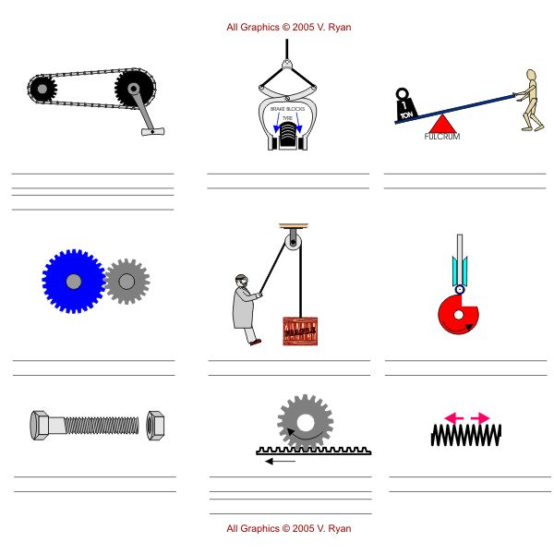

**Key Skills Coverage –Art (Within Computing lessons)**

**Prior Knowledge**

* Year 1/2: Digital Art- Penguins
* Year 3/4: Digital media –Photography*-* Landmarks/Architecture

**Key Skills**

**Digital Art:**

* Record, collect and store visual information using digital cameras etc.
* Present recorded visual images using software
* Use a graphics package to create and manipulate new images.
* Be able to Import an image (scanned, retrieved, taken) into a graphics package.
* Understand that a digital image is created by layering.
* Create layered images from original ideas.

**Key Inspiration**: Islamic Architecture and art

