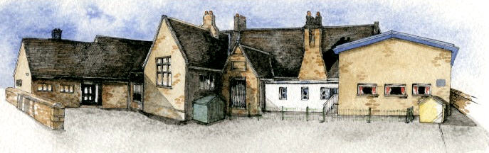
Brabin’s
Newsletter
2nd September 2020
BRABIN’S ENDOWED PRIMARY SCHOOL

  Welcome to the new school year – we hope that you all had an enjoyable summer!  It is wonderful to have the school back up and running today!  A special welcome to our new Reception Class. We are sure that the pupils will settle quickly and we offer them our full support as they start their school life at Brabin’s.  We also warmly welcome Miss Rimmer, as Y5/6 Class teacher.  We are optimistic for an exciting year ahead and welcome a return to full time schooling!  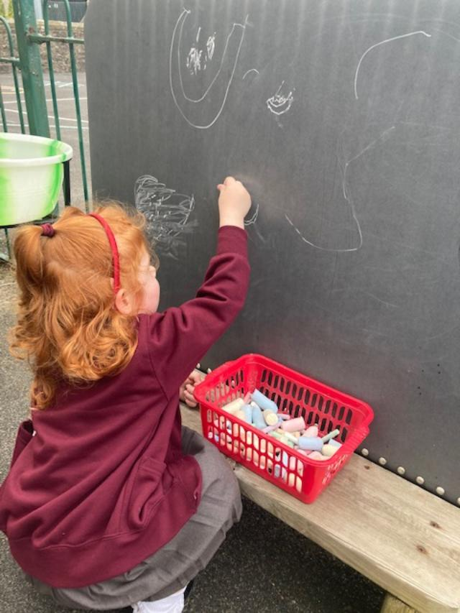  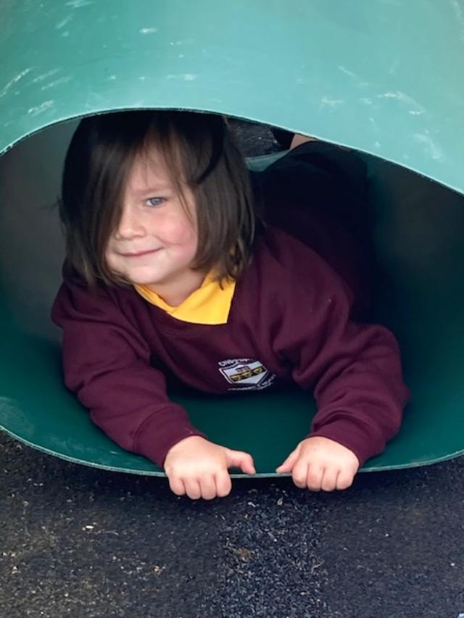    Covid 19  Any future changes in response to Government guidelines or, any review of our re-opening plans, will be communicated to parents as soon as possible. It is essential that everyone adheres to the guidelines in the event of a Covid related illness. This will ensure we can keep our school community safe. |  |   Extra-Curricular Clubs  This half term, Miss Doxey will be delivering Forest School sessions for pupils in Y5/6 (Maximum 12 pupils). This will take place on Mondays 3.15-4.15pm starting on 21st September.  Please email the school office (sarah@brabins.lancs.sch.uk) if you would like a place- note that places are limited.  Sports Cool will deliver a sports club to Y3/4 on Tuesdays – separate letter to follow.  Please note that if your child has been booked into ASC, they will be signed in following the session.    Newsletters will continue to be available on alternate Mondays. These will be available to view on the school website and will also be emailed via Parentmail. head@brabins.lancs.sch.uk.  We will not be sending home paper copies at this time.  Seesaw App  Many of our families used this app successfully during the school closure and it is our intention to continue to use this as a tool to aid communication between home and school. Homework tasks will also be set on this app. A letter will be sent home on Friday (within reading records) with updated details, new accounts and further information. Old log-ins are now expired. |  |   Class PE Days  From next week, the children will need to attend school in their full PE kit on PE days. Please ensure that the children are wearing the appropriate kit including non-branded clothing.  Reception Class: Friday  Y1/2: Tuesday and Wednesday  Y3/4: Monday and Thursday  Y5/6: Monday and Thursday  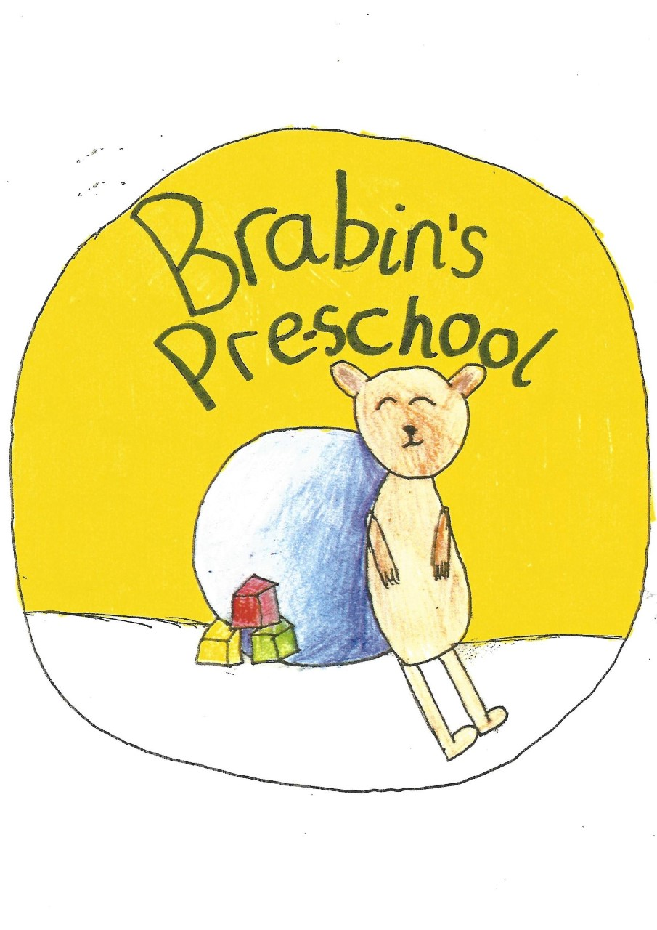  Pre-School  Today we warmly welcomed 4 pupils to our new pre-school. We are looking forward to welcoming more pupils over the next week.  I am sure they will settle quickly into their new environment and will enjoy playing in our play areas with lots of new resources.  Please contact Mrs Wallace to enquire about places.  Office  Dinner payments for this half term are due:  38 days: £87.40  The dinner menu is available to view on the school website.

