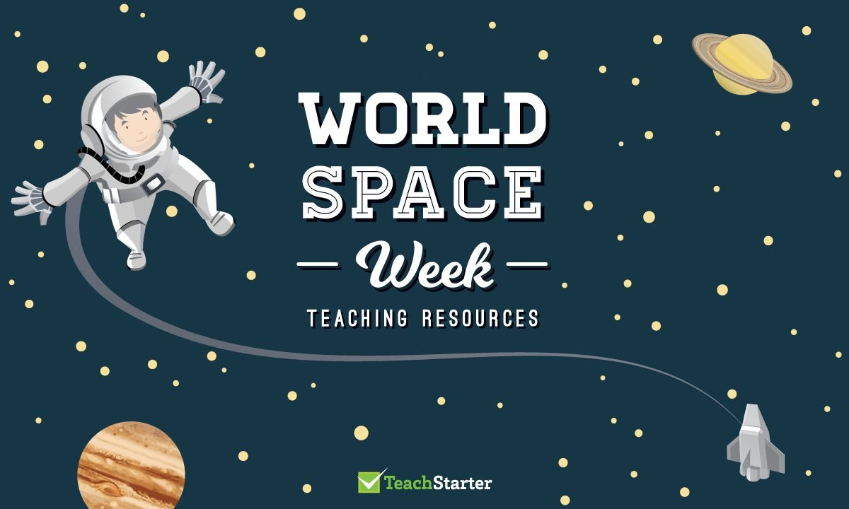

For the final home learning pack of this academic year, the teachers would like you to explore space! Below are a wide range of starting points for activities that you could complete, but the choice is yours. Families with pupils in different classes are welcome to work together on activities. Children working in school will also be taking part in Space Week. We look forward to seeing some of your work!
Writing:  *write and illustrate your own children’s book set in space  *Create a comic strip  *What 10 things would you take with you into space. | Reading:  *enjoy reading a fiction or non-fiction book https://www.lovereading4kids.co.uk/ has free extracts from many books  *Find out about the ‘Science-Fiction genre’ of books | Art:  *Create a piece of space-inspired art. This could be: a drawing, painting, digital art, collage or even a 3D model. See ideas below.
Music:  *Investigate Sci-Fi TV and film theme tunes  *Create your own space inspired piece of music using objects from around your home and record  (the free garage band app is also useful for this) | Science  *Find out all about the different planets in solar system.  https://www.spacekids.co.uk/solarsystem/  Maddie and Greg episodes links below. | History  Find out about previous astronaut’s such as Neil Armstrong.  https://www.nasa.gov/  There are podcasts and eBooks to access.
DT  *Design and create their own space rocket see ideas/links below.  *Baking ideas  Planet cookies  https://www.bbcgoodfood.com/recipes/planet-cookies  Moon Rocks  https://www.goodfood.com.au/recipes/moon-rock-cakes-20130808-2rhtm  Star biscuits  https://www.goodtoknow.co.uk/recipes/shortbread-star-biscuits | PE  Take part in astronaut training camp! Take part in the challenges to see if you have what it takes to be an astronaut!  http://www.spacetoearthchallenge.org.uk/wp-content/uploads/2015/10/PE-Activities.pdf | Useful links:  https://spaceplace.nasa.gov/menu/  https://www.nasa.gov/  https://www.spacekids.co.uk/solarsystem/
Summer Reading Challenge
This year Lancashire's Libraries will be inviting children to get silly for the Summer Reading Challenge. The Summer Reading Challenge will give you the chance to sign up and take part online, with the special www.sillysquad.org.uk website! The Challenge website will be free to access and a place for you to rate and review books and work towards your reading goal. It will also feature video content, games, quizzes, and digital and downloadable activities to complete at home. The Library service will also be providing loads of fun free things to do including book quizzes, a reading group, and an online Lego club!
The theme of the Challenge for this year is Silly Squad, and we want to celebrate funny and silly stories all summer long! From David Walliams to Roald Dahl, and Jacqueline Wilson to Jeff Kinney, there are thousands of hilarious books for you to read, and we can't wait to hear about them!
The Summer Reading Challenge Silly Squad website is now live for you to sign up on, and we in Lancashire will be launching the challenge on Saturday 27th June, so keep an eye on our social media and website for more information!
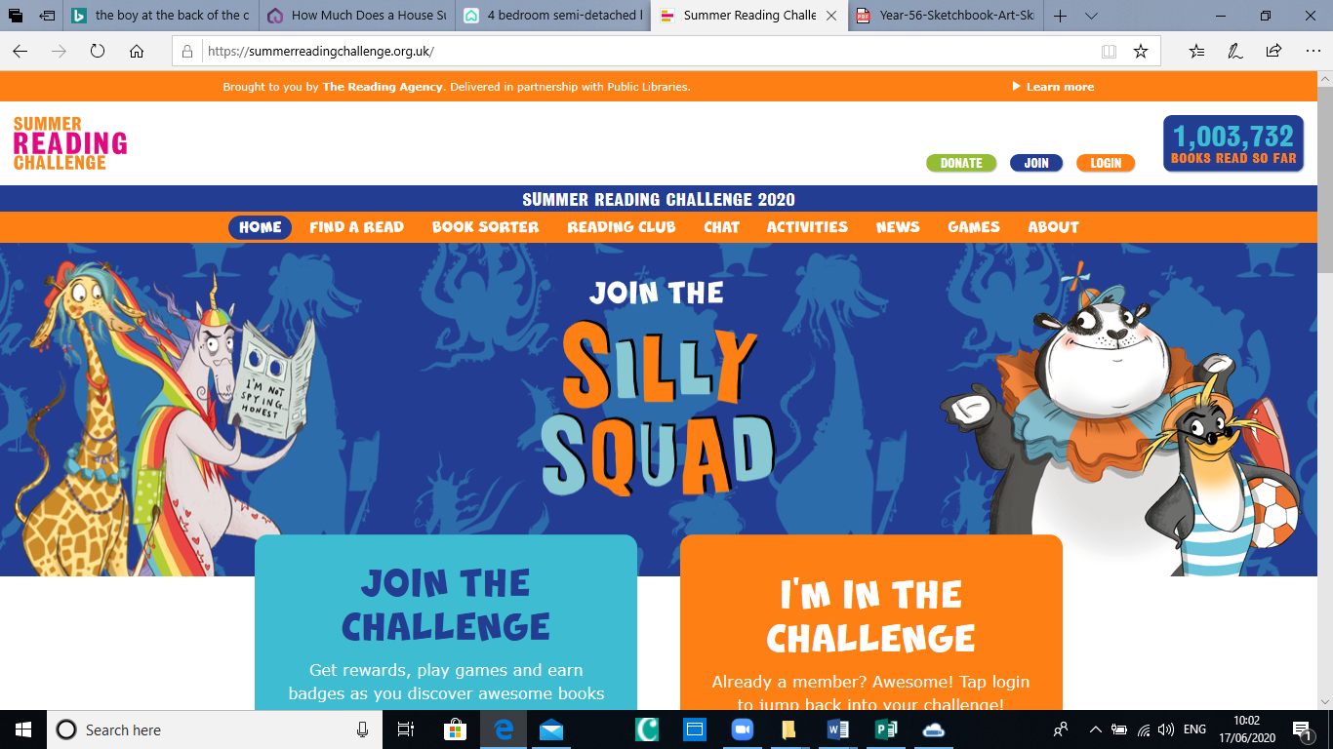
Twitter: @lancspublib
Facebook: @lancslibraries
Website: www.lancashire.gov.uk/libraries-and-archives/libraries/your-library-at-home

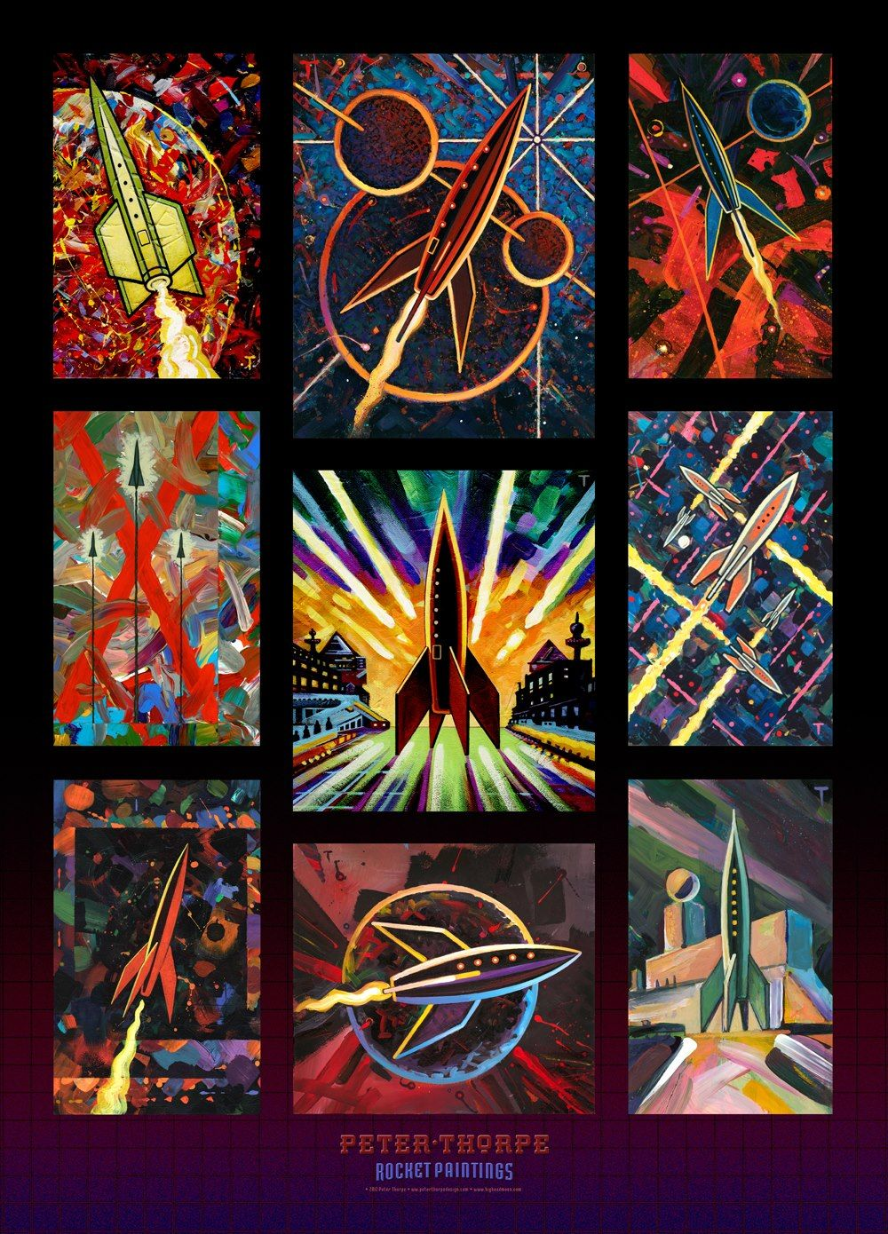
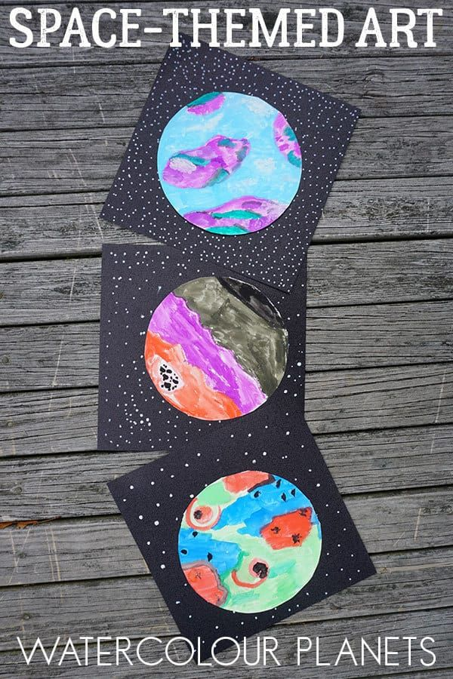
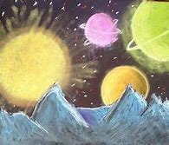
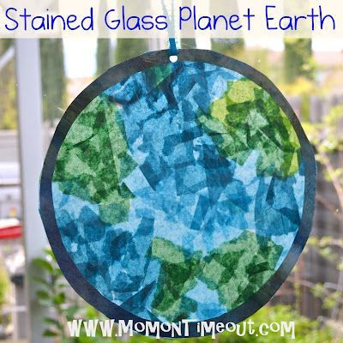
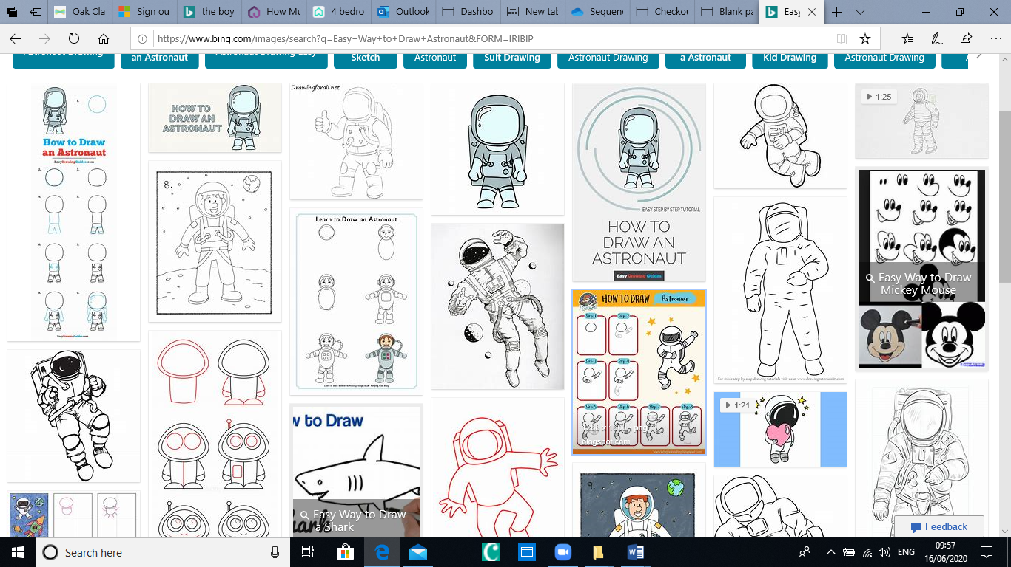
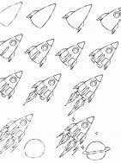
Space Art Ideas

Peter Thorpe rocket inspired paintings

Chalk on black paper

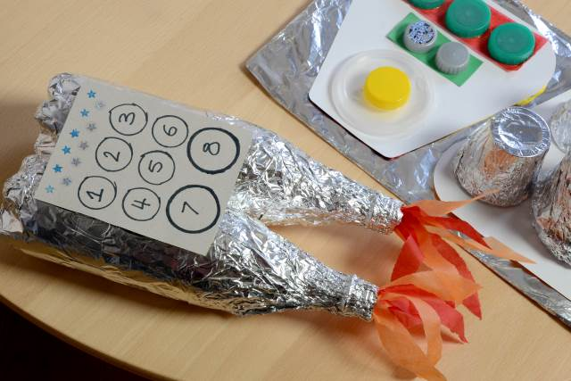
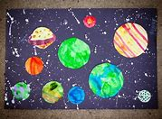

Solar system art work
Making a rocket using a cardboard tube.

Make your own rocket ideas and links

https://www.youtube.com/watch?v=Z3mHbI96Aqw
Make a rocket using a plastic bottle.
https://www.youtube.com/watch?v=HlZ2yyrooS8
Space rocket
https://www.youtube.com/watch?v=hLq_bLg-7c0

Maddie and Greg Let’s Go Live - Mission Space

Episode 11 - How To Make A Pocket Solar System
https://www.youtube.com/watch?v=9oNmSK5jq_c
Episode 12 - 3 Rockets To Build At Home
https://www.youtube.com/watch?v=aq5oHO9uUjw
Episode 13 - Homemade Astronaut Food (& A SPACE SUIT!)
https://www.youtube.com/watch?v=OpksrHQwjAg
Episode 14 - How To LAND ON MARS!
https://www.youtube.com/watch?v=OpksrHQwjAg

NASA Websites

NASA’S AMAZING SOLAR SYSTEM EXPLORATION:
https://solarsystem.nasa.gov/solar-sy...

Where are the planets RIGHT NOW!:
https://solarsystem.nasa.gov/planets/...

SOLAR SYSTEM IN YOUR POCKET: Ogden Trust
https://www.ogdentrust.com/resources/...

