Lancashire SEND  Specialist Teacher Newsletter  No1. March 2020  Home learning ideas for pupils with Special Educational Needs | The Coronavirus outbreak means that parents and carers of young people with SEND are facing uncertainty. We know schools are on the front line and are playing a hugely important role in keeping communities going in these challenging times. If your child is not able to attend school, we want to be able to support you with some practical home learning advice, hints and suggestions. This is an evolving picture, so we hope this newsletter goes some way to support parents and carers through this unprecedented time.

Home Learning
Welcome to the first home learning newsletter for parents and carers of children with special educational needs. The suggestions and practical ideas have been written by specialist teachers working within the Lancashire Specialist Teacher Service. Over the coming weeks, the topics will vary but will cover broad areas of cognition and learning, communication and interaction, social and emotional wellbeing and sensory and physical needs. We welcome any feedback from parents and carers.

Getting Started  - Have a daily plan – include your child's interests and motivators  - Flexibility – be prepared to change the plan  - Chunk activities with a practical, movement break between. | - Developing life skills is also learning.  - Incorporate a range of tools to engage learning e.g. books, apps, garden, household objects.  - Remember every young child can learn, just not on the same day or in the same way.

Supporting Social and Emotional Wellbeing
There is much that each one of us can do to support the wellbeing of those in our lives, including children and young people who may already be vulnerable or suffering from mental health difficulties.
Families play a hugely important part in supporting each other at times of uncertainty or concern. Be alert to how each other is feeling. You might show your worry in different ways to each other – so, if one of you is not feeling worried right now, that’s fine too. With possible changes to daily and weekly routines, do keep sight of what family life feels like and what you can continue to do. These can be the things which make life feel ‘normal’, so they’re important. |  |  |  | Keep your days varied. Think about how you can make the most of the physical space where you live. It may help to create time slots for mealtimes, homework, friends (even if via social media), exercise, TV, etc, and do make sure you all maintain good sleep habits. This routine can shape family life. But remember to be realistic about what you can achieve and don’t create added pressure upon yourselves.
School task  e.g. reading, maths, writing | Sensory Circuit/ movement break/outdoor activity | Break – Practical life skill: e.g. prepare snack,drink | School task  e.g. reading, maths, writing | Sensory Circuit – movement break. Outdoor activity | Practical life skill e.g.  Make the bed, help in the garden, prepare family meal
Suggested Schedule

Sensory circuits structure:
A circuit runs in 3 sections, based on the theories of sensory processing and sensory integration and the practical consideration of providing a structured sensory motor input.
1. Alerting section – to provided vestibular stimulation (allowing fluid in the ears to move about through jumping and head movement), preparing the brain for availability for learning and for the demands of the school environment
2. Organising section – activities that require multi-sensory processing and balance. The individual needs to organise their body, plan their approach and do more than one thing at a time in a set sequential order. Activities such as climbing, hopping, balancing, looking and throwing into a target, hone skills that increase focus, attention span and performance within the classroom setting.
3. Calming section – this is very important to provide input to ensure that as children leave the circuit and enter the classroom they are as calm and centred and ready for the day as possible.
Examples of sensory circuit activities that may be used are:
• Skipping with a rope – individual or rope turned by others or French skipping
• Trampette bounce
• Crash landing – jumping form a trampette onto a crash mat of jumping from high place to low place
• Space race – jumping around course of cones on a space hopper
• Bouncing sphere – bouncing seated on an exercise/fit ball
• Jogging on the spot
• Jumping jacks from crouched position back to crouch
• Hopscotch
• Hoop-la – standing in a hoop and rotating
• Step ups – stepping up and down on a solid bench or platform
• Logroll – roll along line of gym mats, commando crawl
• Balance obstacle course
• Rolling ball – with tummy down on fit ball, walk hands out and back again
• Hand over hand pull – pulling self along using rope attached to wall bars
• Simon says sequences
• Gymnastic ribbon exercises
• Balancing on a wobble board
• Press ups
• Pilates plank exercise
• Crawling
• Ball squash – child lies on a mat and fit ball is rolled slowly up and down the child by an adult, using maintained and constant pressure to calm

You tube has lots of examples of sensory circuits
Supporting Communication and Interaction

Children and young people with speech, language and communication needs (SLCN) have difficulty in communicating with others. This may be because they have difficulty saying what they want to, understanding what is being said to them, or they do not understand or use social rules of communication. The profile for every child with SLCN is different and their needs may change over time. They may have difficulty with one, some or all of the different aspects of speech, language or social communication at different times of their lives.’ (Code of Practice 2015).

- Positioning: be at child level, side by side
- Make sure you have their attention first
- Make learning and interaction fun
- WAIT – let them show you what they can do
- Say LESS
- Repeat, repeat, repeat
- Add a word – build on what your child says
- Offer choices
- Comment don't question
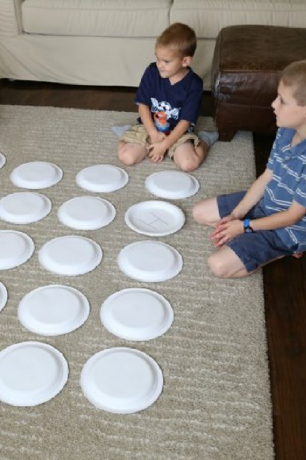
Memory Game
The activity – Paper Plate Big Alphabet Memory Game
Communication and language area(s) of development: Turn-taking, social interaction, attention & listening
In a nutshell – A kingsize variation of the good old pair matching game. Take several paper plates and markers and write some letters if you want your little ones to practice literacy or draw shapes, animals and other items if it’s time to build their vocabulary.
What you need –
- A dozen Paper Plates
- Marker Pens

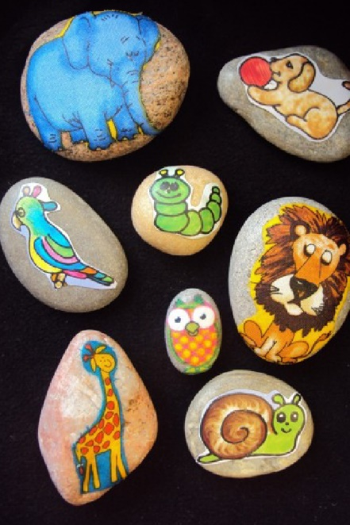
Story Stones
The activity – Homemade Story Stones by Happy Hooligans
Communication and language area(s) of development: Expressive language, vocabulary, turn-taking, attention and listening
In a nutshell – Story stones are essentially very simple prompts for narrative play. All you need to do is get some flat and smooth stones from a craft shop or a beach and decorate them with pictures of objects or animals. Choose one of the stones and start a tale based on the picture on it, then encourage your child to draw more stones and continue the story.
What you need –
- Small Stones
- Acrylic paint, Stickers or PVA glue and Magazine Pictures Cut-Outs

Look out for ideas for older children and teens in our next newsletter.

Supporting Literacy

Young people can have difficulty in reading, writing, spelling and comprehension. Each newsletter will focus on a different aspect of literacy support.

SNIP Literacy Programme 1,2 and 3 for both Primary and Secondary age pupils. Resources are free to download at http://www.snip-newsletter.co.uk/downloads.php
The programme uses the primary and secondary curriculum words alongside high frequency words to support the recognition and spelling of words that KS1-KS4 pupils will need in order to read and write fluently.

Activities include
- Look, say, cover, write and check
- Tracking
- Anagrams
- Fill in the missing letters/words
- Crossword and word search

Paired Reading - reading skills

- Your voice is your single most important tool when telling a story.
When reading aloud, our facial expressions also help adults and children understand the meaning of the words, as well as increasing overall enjoyment and engagement.
Important things to consider: pitch, tone, volume and rate.
- Choose a book that your child can access. Both fiction or non-fiction
Provide much opportunity to listen to and use rhyme e.g. poems, make rhyme books, make rhyming sentences (the fat cat sat on the mat) and illustrate them.
- Play lots of games where the child has to isolate the first sound in a word e.g. I spy.
- Teach picture links with alphabet sounds e.g. alphabet mats.

- Use predictable texts that encourage re-reading and texts at an appropriate level for independent reading.

- Encourage your child to point to words in the text as they are read.

Websites
Join Lancashire Library – you can access a great range of e-books and e-audiobooks for free.
https://www.lancashire.gov.uk/libraries-and-archives/libraries/digital-library/
You Tube – Mr Mc Phonics for early years and KS1 – fun, engaging phonics lessons for children to watch.

Supporting Number
- It’s not uncommon for young people to have trouble with maths.
- Math difficulties can show at different ages and in lots of ways.
Some children who have trouble with maths just need more time and practice to learn maths skills. You might see your child struggling with very simple concepts, like “more” and “less” and “bigger” and “smaller. Your child might also have trouble understanding amounts or the order of things in a list, such as “first,” “second” or “third.” Think about how you can increase confidence in these concepts completing everyday tasks. "How many more spoons do we need?" "Who has less chips?".
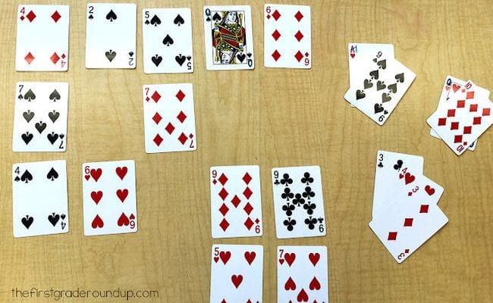
1. Try for a total of 10.
Play this maths card game alone or as a team. Lay out 20 cards on the table (leave out face cards or change them to equal 0, while aces equal 1).
Take turns to remove sets of cards that add up to 10, ultimately trying to remove all the cards from the table. It’s harder than you think!

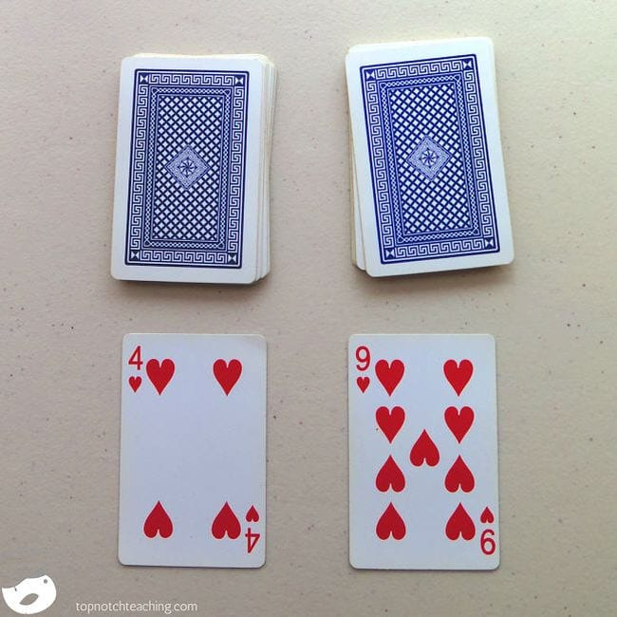
2. Do some basic fast facts practice.
Give your flash cards a rest and practice facts with maths card games instead.
Simply lay down two cards from the deck (remove the face cards first) and add, subtract, or multiply them. Kids can work on this alone, or you can make it a contest to see who can call out the correct answer first.

3. The Maths factor https://www.themathsfactor.com/

Let Carol teach your child Maths during this difficult period
Age 4-12 years
Matched to the National Curriculum.
Free for the duration of the UK Schools closure period.

