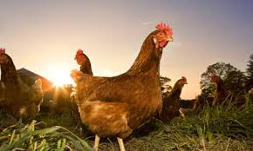

How to look after the chickens at weekend

Morning
- Let the chickens out of the chicken house.
- Give them 2 handfuls of food and water.
- Clean the toilet tray out if dirty using the wheel barrow and fork.
Take home any eggs.
Evening
- Put the chickens back into their house.
- Make sure they have water in their house pen and give them 2 more handfuls of food (this will help to get them into their house).

Thank you for looking after our chickens over the weekend.

School Chickens
We are looking for volunteers to help us look after the chickens at the weekends. We have attached a sheet telling you what you would need to do if you volunteer.

If you and your child/children would be interested in looking after the chickens at the weekend and joining the rota, please could you fill out this form and return it to the school as soon as possible.
Thank you!

Brabins School Eco-committee.

I would be willing to help look after the chickens at the weekend.

Parent:

Child:

