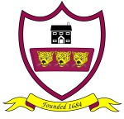
Brabin’s Endowed School
Mission Statement
“Love one another as I have loved you.”
John 15:12

At Brabin’s we are more than friends- we love and value one another as part of God’s family. We respect each other and strive to achieve our best when we are learning and in all we do.
Year 6’s explanation of our mission statement: This is our vision at Brabin’s and shows who we really are. Our small school brings us together to make us more like one big family. We are a Church School who strive to follow Jesus in his footsteps; God, Jesus and the Holy Spirit are always by our sides helping us to stay strong and bind us all together. At Brabin’s we respect each other and our school environment no matter what. Our positive attitude towards learning ensures that each and every one of us reaches our full potential and can leave Brabin’s in Year 6 feeling proud of all our achievements. Brabin’s School gives each and every one of us the chance to shine in all that we do.

