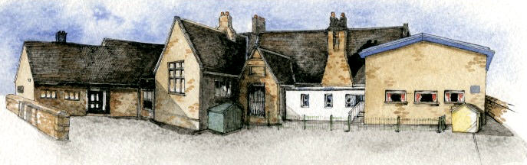
Brabin’s
Newsletter
3rd September 2019
BRABIN’S ENDOWED PRIMARY SCHOOL

  Welcome to the new school year – we hope that you all had an enjoyable summer!  A special welcome to our new Reception Class. We are sure that the pupils will settle quickly and we offer them our full support as they start their school life at Brabin’s.  We also warmly welcome Mrs Cook as our new After School Club/Breakfast Club Assistant.  We have a busy term planned with lots of new and exciting opportunities!  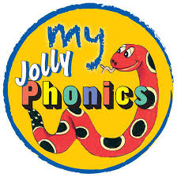  Phonics Information Evening  All our current Reception parents are invited to a short, informal session on how to support your child with phonics at home. The event will provide an opportunity to see how phonics is delivered in school.  This meeting will take place on Wednesday 25th September at 3.20p.m. Miss Doxey and Miss Garth will lead the meeting and provide the relevant information. |  |   May Day Bank Holiday 2020  You may be aware that the date has been changed in 2020 to commemorate the 75th anniversary of VE Day.  This means that we will now be in school on Monday 4th May 2020 and closed on Friday 8th May 2020.    Extra-Curricular Clubs  This half term, Miss Doxey will be delivering Forest School sessions for pupils in Y1/2. This will take place on Mondays 3.15-4.15pm starting on 16th September.  Sports Cool will deliver a sports club to KS2 on Tuesdays – see separate letter.  Please note that if you child has been booked into ASC, they will be signed in following the session.  Please return the slip and note that places are limited.    Newsletters will continue to be available on alternate Mondays. Please return the slip overleaf to notify us how you would like to receive the newsletter this year. (Please return by Friday 6th September or we will assume you will access the newsletter via the website). |  | Office  Dinner payments for this half term are due:  34 days: £78.20  Coming up!    Harry Potter Day  20th September 2019  The whole school will be participating in some exciting activities during the day.  Please note that costumes/accessories are optional!    Y5/6 Shakespeare Performance  Y5/6 will be performing ‘Romeo and Juliet’ at the Shakespeare Festival on Tuesday 5th November at the Empire Theatre, Blackburn.    Friends of Brabin’s  Autumn Dinner Dance  Friday 8th November 2019 at Chipping Village Hall.  Drinks reception followed by a 3 course meal and dancing!  Tickets: £25  Please support our fundraising evening.

What’s going on this half term…

19th September | Football Tournament at Barton St Lawrence -4pm – separate letter
20th September | Harry Potter Day
25th September | Phonics Information session for Reception parents at 3.20pm in school
27th September | Y3/4 Class visit to Eureka – separate letter
30th September | Y5/6 Shakespeare Workshop at Blackburn Empire theatre -pm
3rd October | Cluster Football and Netball at LHS- separate letter
11th October | Harvest Assembly in school –children to bring in donations for the Foodbank on this day
13th October | Harvest Festival at St Bartholomew’s - am
17th October | Open Evening 6.30pm-8pm
Half Term: Monday 21st October – Friday 25th October
Inset Day: Monday 28th October 2019
Pupils return to school on Tuesday 29th October 2019

Date for your diary:

7th November – Parents Evening

Newsletters
Please can all families return the slip (by Friday 6th September) with the preference to receive the newsletter for the start of the new academic year:
Name: _________________________________________
Please circle how you would like to receive the Newsletter by: email / paper copy / view on website

Email address (if appropriate): ______________________________

KS1 Forest School Club
______________________ would like to participate in the Forest School sessions (Monday’s 3.15pm - 4.15pm, 16th September to 14th October) with Miss Doxey.
Signed:_____________________________ date ________________

